USSD-Based Marks Appeal System with PIN-Secured Student Authentication
Case Study of University Libre De Kigali

BIKORIMANA Jaen Baptiste
2205000458

Under the guidance of

a research proposal project submitted to the university of Kigali in partial fulfillment of the requirements for the award of a bachelor’s degree with honors in information technology.

MAY, 2026

DECLARATION
I, BIKORIMANA Jaen Baptiste, declare that this work entitled” USSD-Based Marks Appeal System with PIN-Secured Student Authentication: A Case Study of University lible de Kigali (ULK)” is my own original work. This proposal has been done by me and has not received any previous academic credit at this or any other university or institution of high education in Rwanda.

BIKORIMANA Jaen Baptiste
2205000458

Signature:………………………… Date:…………………………………..

APPROVAL

This is to acknowledge that this dissertation has been submitted with my approval.

Supervisor: Mr. ISHIMWE Olivier Angel Kevin

Signature:………………………. Date:……………………....

DEDICATION
To the Almighty God for his guidance,
To my beloved Parents,
To my dear brothers and sisters,
To my classmates, friend and colleagues,
To all our friends,
This memoire is dedicated.

ACKNOWLEDGEMENT
I offer my special thanks to Almighty God who protected me till now and from whom knowledge comes. I cannot forget to thank the Lecturers of the University of Kigali, especially those in Computer Science and Information Technology, for their immense contribution through the courses taught. Special thanks go to my supervisor, Mr. ISHIMWE Olivier Angel Kevin, who generously spent his time and committed himself to guiding us, transforming our raw ideas into a meaningful, practical system.
I also thank the University of Kigali administration and all the lecturers in the Department of Information Technology for their continuous support through this academic journey. I extend my gratitude to the Head of the Department of Information Technology.
Special thanks are due to my classmates who made sacrifices by providing me with mutual support and the necessary collaborative environment to attain a quality education.
I owe my deepest gratitude to my family and the government of Rwanda for providing the necessary resources and requirements throughout my educational process.

May the Almighty God bless you all!

LIST OF FUGURES
Figure 1: Conceptual Framework of the USSD-Based Marks Appeal System with PIN Security 15
Figure 2: Waterfall model 19
Figure 3admin login page 29
Figure 4admin dashboard 29
Figure 5 admin System Maintenance 30
Figure 6: HOD login 31
Figure 7 HOD Dashboard 31
Figure 8 HOD Manage Results 32
Figure 9Level 0 DFD 34
Figure 10:DFD Level 1 diagram 35
Figure 11Data Flow Diagram Level 2 (Authenticate Student) 36
Figure 12 user case diagram 38
Figure 13: Sequence Diagram 1(Student Submits an Appeal) 39
Figure 14 :Student USSD Portal 40
Figure 15Student USSD Portal 2 40
Figure 16 Submit Student USSD Portal 41
Figure 17:Sequence Diagram 2 42
Figure 18 Entity Relationship Diagram (ERD) 48
Figure 19:USSD Welcome Menu shows the Africa's Talking USSD Simulator displaying the main menu with four options 58
Figure 20:Marks Display shows the USSD response listing module names and their corresponding marks for a test student ID. 58
Figure 21:Appeal Submission Confirmation shows the END message after completing the full appeal flow. 59
Figure 22:Administrator Login Page shows the Bootstrap-styled login form. 59
Figure 23:Administrator Dashboard shows the appeals management table with all columns. 60
Figure 24:Status Updated shows the dashboard after an administrator has updated an appeal status to Approved. 60

LIST OF TABLES
Table 1: population 17
Table 2: Student Survey Results 24
Table 3: Administrative Staff Survey Results 25
Table 4: DFD Level 1 Process Descriptions 35
Table 5: DFD Level 2 Authentication Process Decomposition 37
Table 6:Normalisation Summary 43
Table 7:Data Dictionary students 44
Table 8: Data Dictionary admins 44
Table 9:Data Dictionary marks 45
Table 10: Data Dictionary appeal_status 45
Table 11:Data Dictionary appeals 46
Table 12:Data Dictionary pin credentials 47
Table 13:Data Dictionary access_audit 48
Table 14:Unit Testing Results 62
Table 15:Validation Testing Results 63
Table 16:Integration Testing Results 64

Table of Contents
DECLARATION i
APPROVAL ii
DEDICATION iii
ACKNOWLEDGEMENT iv
LIST OF FUGURES v
LIST OF TABLES vi
ABSTRACT xiii
CHAPETER ONE: GENERAL INTRODUCTION AND BACKGROUND TO THE STUDY 1
1.0 Introduction 1
1.1 Background to the Study 1
1.2 Statement of the Problem 3
1.3 Objectives of the Study 4
1.3.1 General Objective 4
1.3.2 Specific Objectives 4
1.4 Research Questions 4
1.5 Significance / Importance of the Study 5
1.5.1.to researchers 5
1.5.2. Significance to University Libre de Kigali (ULK) 5
1.5.3. Significance to the Public 5
1.6 Scope of the Study 6
1.6.1. Content Scope 6
1.6.2. Geographical Scope 6
1.6.3. Time Scope 6
1.8 Limitations of the Study 6
CHAPETR TWO: LITERATURE REVIEW 7
2.0 Introduction 7
2.1 Definition of Key Concepts 8
2.2 The Body: Key Concepts, Theories, and Related Studies 9
2.2.1 Empirical Review 9
2.3 Theoretical Review 12
2.3.1. Existing System 12
2.3.2. Proposed System 13
2.3.3 Summary of the Research Gap 14
2.4 Conceptual Framework 14
CHAPETER THREE: RESEARCH METHODOLOGY 16
3.0 Introduction 16
3.1 Research Design 16
3.2 Population and Selection of the Sample 16
3.3 Tools for data collection / Instrumentation 17
3.4 Collection of data 18
3.5 Data Collection Tools 19
3.5.1. Software Engineering Methods 19
3.6 Validity and Reliability 20
3.6.1. Validity 20
3.6.2. Reliability 21
3.7 Ethical Considerations 21
CHAPTER IV: SYSTEM ANALYSIS, DESIGN AND IMPLEMENTATION 23
4.1 Introduction 23
4.2 Data Analysis and Presentation 23
4.2.1 Student Survey Results 23
4.2.2 Administrative Staff Survey Results 24
4.3 Interpretation of Findings 25
4.4 Summary of Findings: Needs of the Proposed System 26
4.5 Description of the Existing System 26
4.6 Description of the New System 27
4.6.1 Modules and Functional Description 27
4.6.2 System Configuration: Hardware and Software Requirements 32
4.6.3 Technology (Platform) to be Used 33
4.6.4 Non-Functional Requirements 33
4.7 Illustration of the New System 34
4.7.1 Data Flow Diagrams and Processes 34
4.7.2 Use Case and Sequence Diagrams 37
4.7.3 Database Normalization 42
4.7.4 Data Dictionary 43
4.7.5 Entity Relationship Diagram (ERD) 48
4.7.6 Physical Data Model 48
4.8 Architecture of the Front-End of the System 51
4.8.1 USSD Interface Architecture 51
4.8.2 Web Portal Architecture 51
4.9 Implementation and Coding 52
4.9.1 Introduction 52
4.9.2 Description of Implementation Tools and Technology 52
4.9.3 Screenshots and Source Codes 53
4.10 Testing 60
4.10.1 Introduction 60
4.10.2 Objective of Testing 61
4.10.3 Unit Testing Outputs 61
4.10.4 Validation Testing Outputs 62
4.10.5 Integration Testing Outputs 63
4.10.6 Functional and System Testing Results 64
4.10.7 Acceptance Testing Report 65
CHAPTER FIVE: CONCLUSIONS AND RECOMMENDATIONS 67
5.0 Introduction 67
5.1 Conclusions 67
5.1.1 Conclusion on Objective One: Analysis of the Existing System 67
5.1.2 Conclusion on Objective Two: PIN Authentication Mechanism 68
5.1.3 Conclusion on Objective Three: USSD Student Interface 68
5.1.4 Conclusion on Objective Four: Web Administration Portal 68
5.1.5 Conclusion on Objective Five: Testing and Evaluation 69
5.1.6 General Conclusion 69
5.2 Recommendations 70
5.2.1 Recommendations to University Libre de Kigali 70
5.2.2 Recommendations to ICT Developers and System Implementers 71
5.2.3 Recommendations to Policymakers and Higher Education Regulators 71
5.3 Areas for Further Research 72
REFERENCES 74
APPENDICES 76
Appendix A: Student Questionnaire 76
Appendix B: Administrative Staff Interview Guide 77
Appendix C: System Testing Summary 78
Appendix D: System Architecture Overview 79

LIST OF ABBREVIATION

AMS | Appeal Management System
API | Application Programming Interface
CRUD | Create, Read, Update, Delete
DBMS | Database Management System
ERD | Entity Relationship Diagram
GSM | Global System for Mobile Communications
GUI | Graphical User Interface
HTTP | Hypertext Transfer Protocol
HTTPS | Hypertext Transfer Protocol Secure
ICT | Information and Communication Technology
IS | Information System
IT | Information Technology
KPI | Key Performance Indicator
LAN | Local Area Network
MAS | Marks Appeal System
MIS | Management Information System
OTP | One-Time Password
PIN | Personal Identification Number
PSA | PIN-Secured Authentication
RDBMS | Relational Database Management System
SAR | Student Appeal Request
SDLC | System Development Life Cycle
SIM | Subscriber Identity Module
SMS | Short Message Service
SQL | Structured Query Language
SRD | Software Requirements Document
SRS | Software Requirements Specification
UBMAS USSD-Based Marks Appeal System
ULK University Libre de Kigali
UML Unified Modeling Language
URL Uniform Resource Locator
USSD Unstructured Supplementary Service Data
WAN Wide Area Network

ABSTRACT
The management of student academic records is a critical function in higher education institutions. Traditional marks appeal processes are often characterized by paperwork, delays, and security challenges, which can lead to inefficiencies and dissatisfaction among students and administrators. This study proposes a USSD-Based Marks Appeal System with PIN-Secured Student Authentication for the University Libre de Kigali. The system leverages Unstructured Supplementary Service Data (USSD) technology to provide students with a simple and accessible platform for submitting and tracking marks appeal requests using mobile phones without requiring internet connectivity. The proposed system incorporates a Personal Identification Number (PIN) authentication mechanism to ensure that only authorized students can access and submit appeal requests. Through the USSD interface, students can securely log in, view examination results, lodge appeals, and receive status updates regarding their applications. The system is designed to improve data security, reduce processing time, and enhance communication between students and academic administrators. Additionally, the centralized database enables efficient management and monitoring of appeal records. The implementation of this system is expected to streamline the marks appeal process at the University Libre de Kigali by increasing accessibility, transparency, and operational efficiency. By minimizing manual procedures and providing real-time interaction through mobile devices, the system contributes to improved service delivery and student satisfaction. The study demonstrates how USSD technology combined with secure authentication can provide a cost-effective and reliable solution for academic record management in higher learning institutions.
Keywords: USSD, marks appeal, PIN authentication, SHA-256, student information system, mobile-based academic services, Flask, MySQL, Africa's Talking, University Libre de Kigali

CHAPETER ONE: GENERAL INTRODUCTION AND BACKGROUND TO THE STUDY

1.0 Introduction
This chapter provides a general introduction to the study. It outlines the background of the problem being investigated, articulates the statement of the problem, defines the objectives and research mquestions, highlights the significance of the study to various stakeholders, specifies the scope within which the study is conducted, acknowledges anticipated limitations, and defines the key terms used throughout the proposal.
The rapid advancement of mobile technology in sub-Saharan Africa has created both opportunities and challenges for academic institutions seeking to digitalize their administrative services. In Rwanda and the broader African region, universities continue to rely on manual, paper-based processes for academic mark appeals a situation that is increasingly untenable given the scale of student populations and the growing expectations for transparency and responsiveness. This study proposes the development of a Unstructured Supplementary Service Data (USSD)-based marks appeal system, uniquely enhanced with a Personal Identification Number (PIN) security mechanism, to address these challenges comprehensively.

1.1 Background to the Study
Globally, higher education institutions have progressively shifted from paper-based administrative systems to fully digital student management platforms. International platforms such as Blackboard, Moodle, SAP Student Lifecycle Management, and Oracle PeopleSoft Campus Solutions now underpin the academic operations of universities worldwide, providing students with digital access to marks, transcripts, and appeal procedures (Farhan & Razmak, 2019). In high-income countries, these systems are supported by robust internet infrastructure and near-universal smartphone ownership, enabling seamless access for nearly all students.
However, even in these advanced environments, security vulnerabilities in student-facing academic portals have been documented. A common vulnerability is the reliance on a single identifier typically a student number as both the identity and the authentication credential. Studies in cybersecurity and digital identity management have consistently shown that single-factor authentication based on a publicly known identifier presents unacceptable risk to the privacy and integrity of personal academic records (NIST, 2020). The proposed PIN security layer directly addresses this widely recognized gap.
Across sub-Saharan Africa, internet penetration and smartphone ownership, while growing, remain significantly lower than global averages. According to the International Telecommunication Union (ITU, 2021), approximately 33% of individuals in Africa use the internet, compared to a global average of 63%.
This disparity means that web-based academic portals which are standard in developed countries are inaccessible to a substantial proportion of African university students, particularly those from rural or low income backgrounds. Despite this, mobile phone penetration in Africa is high and continues to grow. A technology available on virtually every GSM-capable handset from the most basic feature phone to the latest smartphone is USSD. USSD operates over the GSM signaling channel without requiring internet access, a data bundle, or any application installation. It has been widely deployed for mobile financial services across Africa, most notably M-Pesa in Kenya, which serves over 50 million users (Africa's Talking, 2023). The success of USSD-based financial services in Africa provides a strong precedent for applying the same technology to academic administrative services.

In Rwanda, the higher education sector has grown significantly since 2000, with institutions such as the University of Rwanda, the University of Kigali , and several private universities enrolling tens of thousands of students annually. The Rwandan government's Vision 2050 and Digital Rwanda strategy emphasise the digitization of public services and the development of an inclusive knowledge economy (Republic of Rwanda, 2020). However, academic administrative processes including marks appeals at many Rwandan universities remain manual and paper-based.
Students who wish to appeal a mark typically must visit the examination office in person during working hours, submit a handwritten form, and await a response that may take weeks with no tracking mechanism. Students in remote areas, those with disabilities, or those managing work and family commitments are disproportionately disadvantaged. Furthermore, no existing USSD-based system in the Rwandan higher education context provides students with a secure, PIN-authenticated mechanism for accessing their marks and submitting appeals. This study fills that gap.
Kigali Independent University (ULK), known in French as Université Libre de Kigali, is one of the leading private higher learning institutions in Rwanda. The university was founded on 15 March 1996 by Prof. Dr. Rwigamba Balinda with the aim of providing quality higher education and contributing to the socio-economic development of Rwanda through teaching, research, and community service. ULK was established during the post-genocide reconstruction period when the country required qualified human resources to support national development. Since its creation, the university has expanded its academic programs and infrastructure to meet the growing demand for higher education in Rwanda (Kigali Independent University, n.d.).
Over the years, ULK has developed into a reputable institution offering undergraduate and postgraduate programs in various disciplines, including computer science, business administration, law, economics, education, and social sciences. The university initially operated from the St. Paul buildings before establishing its first campus in Kacyiru and later relocating its main administrative and academic activities to the Gisozi campus in 2007. This expansion reflects the institution’s commitment to providing a conducive learning environment and enhancing access to quality education for students from Rwanda and beyond (Wikipedia Contributors, n.d.; Kigali Independent University, n.d.).
ULK operates under the motto “Science and Conscience” and is guided by a vision of becoming a remarkable university for excellence at the heart of Africa. Its mission focuses on educating students, conducting research, and serving the community while promoting ethical values and professional competence. As the university continues to embrace technological advancement in academic and administrative processes, there is a growing need to improve service delivery through digital solutions. One area requiring improvement is the management of marks appeal processes, which often involve manual procedures that may result in delays, inefficiencies, and limited accessibility for students. Therefore, the development of a USSD-Based Marks Appeal System with PIN-Secured Student Authentication is intended to enhance efficiency, accessibility, transparency, and security in handling students’ marks appeal requests at ULK (Kigali Independent University, n.d.).

1.2 Statement of the Problem
The marks appeal process at the University of Kigali and similar institutions in Rwanda is characterised by inefficiency, inaccessibility, opacity, and insecurity. While some institutions have introduced basic student web portals for result publication, these portals suffer from a fundamental security flaw: they authenticate students using only their registration number a piece of information that is widely known among fellow students, academic staff, and administrative personnel. Any individual who obtains a student's registration number can therefore access that student's academic records, impersonate them in appeal submissions, or interfere with their academic data. This constitutes a significant breach of academic privacy and data integrity.
Beyond the security dimension, the existing process excludes students who lack internet access or smartphones a considerable proportion of the student body. There is no mechanism for students to receive real-time updates on the progress of their appeal. Administrative staff are burdened with manual recordkeeping, which is error-prone, time-consuming, and difficult to audit.
The novelty of this research lies in its dual contribution: it is the first study in the Rwandan higher education context to propose a USSD-based marks appeal system with integrated PIN authentication. By requiring students to create and use a personal 4-digit PIN which is stored as a SHA-256 cryptographic hash the system prevents unauthorized access. Combined with a 3-strike lockout policy, an OTP-based reset mechanism, and a comprehensive access audit trail, the proposed system represents a substantive advancement over existing approaches.

1.3 Objectives of the Study

1.3.1 General Objective
The general objective of this study is to design, develop a USSD-based marks appeal system with an integrated PIN security mechanism for university students at the University of Kigali, Rwanda.

1.3.2 Specific Objectives
- To analyses the current marks appeal process at the University of Kigali and identify specific pain points experienced by students and administrative staff.
- To design a PIN-secured student authentication mechanism that prevents unauthorized access to marks and appeal functions via USSD, incorporating SHA-256 hashing, a 3-strike lockout policy, and OTP based PIN reset.
- To develop a secure Flask-based web administration portal enabling academic staff to log in, review all submitted appeals, and update their statuses.
- To test and evaluate the developed system for security effectiveness, functional correctness, usability, and accessibility.

1.4 Research Questions
This study is guided by the following research questions:
- What are the current challenges and limitations associated with the existing marks appeal process at the University of Kigali?
- How can a PIN-secured student authentication mechanism be designed to prevent unauthorized access to marks and appeal services through USSD?
- How can a Flask-based web administration portal be developed to enable academic staff to review submitted appeals and update their status efficiently? iv. To what extent does the developed USSD-Based Marks Appeal System meet the requirements of security, functional correctness, usability, and accessibility?

1.5 Significance / Importance of the Study
The findings of this study are expected to be significant to the following stakeholders:

1.5.1.to researchers
This study provides the researcher with an opportunity to apply the knowledge and skills acquired in Information Technology, particularly in software development, database management, mobile technologies, and information security. Through the design and implementation of a USSD-Based Marks Appeal System with PIN-Secured Student Authentication, the researcher gains practical experience in solving real-world institutional challenges using technology. The study also enhances the researcher's research, analytical, problem-solving, and project management skills, which are essential for professional and academic development.

1.5.2. Significance to University Libre de Kigali (ULK)
The study is expected to benefit University Libre de Kigali (ULK) by improving the efficiency and effectiveness of the marks appeal process. The proposed system will provide students with a convenient and accessible platform for submitting appeal requests through USSD technology without requiring internet access. The implementation of PIN-secured authentication will strengthen the security and confidentiality of students' academic records by preventing unauthorized access. In addition, the system will reduce paperwork, minimize processing delays, improve record management, and enhance transparency and accountability in handling marks appeals. This will ultimately contribute to better service delivery and increased satisfaction among students and academic staff.

1.5.3. Significance to the Public
The study contributes to the wider adoption of digital technologies in educational institutions and other organizations that require secure and efficient service delivery. Students, parents, educators, and policymakers may benefit from the findings by understanding how USSD technology can be utilized to provide accessible services even to users with basic mobile phones and limited internet connectivity. Furthermore, the study serves as a valuable reference for future researchers, software developers, and institutions interested in implementing secure mobile-based systems for academic administration and other public services. The research therefore supports technological innovation and digital transformation within the education sector and society at large.

1.6 Scope of the Study

1.6.1. Content Scope
This study covers the design, development, and evaluation of a USSD-based marks appeal system with PIN secured student authentication. The system encompasses four functional domains: (a) student authentication via PIN, (b) marks viewing, (c) appeal submission, and (d) appeal status tracking. The administration portal covers administrator login, appeal dashboard, and status management. The study includes the design of a relational database with seven tables, a Python Flask backend, and integration with the Africa's Talking USSD API. The study does not extend to payment processing, biometric authentication, real-time integration with a live Student Information System (SIS), or the development of a native mobile application. These are identified as directions for future research.

1.6.2. Geographical Scope
The study is conducted in the context of the University lible de Kigali, Rwanda. Data collection (interviews and surveys) will be carried out with students and administrative staff at this institution. However, the system architecture and methodology are designed to be transferable to other higher education institutions in Rwanda and the broader sub-Saharan African region.

1.6.3. Time Scope
This study was conducted over a period of four months, from February 2026 to June 2026, covering all phases of the research from topic selection and proposal writing through to system implementation, testing, and final defense presentation.
The four-month period was structured as follows:
Month | Phase | Activities
Month 1 (February 2026) | Planning & Design | Topic selection, proposal writing, literature review, research instrument design, and database schema planning
Month 2 (March 2026) | Data Collection & Development | Survey administration to 372 students and 19 HODs, semi-structured interviews, and system development Sprints 1-3 (USSD menu, database setup, PIN authentication)
Month 3 (April 2026) | Development & Testing | System development Sprints 4-6 (appeal submission, status tracking, admin portal, HOD portal, audit logging), unit testing, validation testing, and integration testing
Month 4 (May - June 2026) | Evaluation & Reporting | Functional testing, acceptance testing, report writing, corrections, and final defense preparation
The system was fully implemented and deployed on Render.com by the end of Month 3, and all testing phases were completed within Month 4. This study does not cover events or system developments occurring after June 2026.

1.8 Limitations of the Study
The following anticipated limitations have been identified, along with the strategies the researcher intends to employ to mitigate their potential impact on the quality and validity of the research outcomes:
Limited Sample Size: The study targets a minimum of 30 student survey respondents from the School of ICT, which may not fully represent the diversity of the broader student population. To mitigate this, the researcher will use stratified selection to ensure representation across year groups and study programmers and will triangulate survey findings with interview data from administrative staff.
USSD Sandbox vs. Live Environment: The system will be tested using the Africa's Talking USSD sandbox rather than a live production USSD short code, due to regulatory and cost constraints. This may not replicate all real-world network conditions (e.g., 2G latency, carrier-specific session handling). To mitigate this, the researcher will simulate varying network delays during testing and document any deviations from the sandbox environment.
Access to Administrative Staff: The availability of academic and administrative staff for interviews may be constrained by institutional schedules and academic calendars. The researcher will seek formal institutional approval in advance, offer flexible interview scheduling (including virtual interviews), and provide alternative data collection instruments (written questionnaires) for staff who cannot participate in interviews.
Scope of Security Testing: While the study includes PIN bypass attempts and brute-force simulation, a comprehensive penetration test of the deployed system is beyond the scope of this proposal. This limitation will be disclosed in the study findings, and recommendations for a formal security audit prior to production deployment will be made.
Generalizability: As the study is conducted at a single institution, findings may not be directly generalizable to all Rwandan universities or institutions in other African countries. To address this, the researcher will discuss the transferability of the system design and findings in the conclusion chapter, identifying which aspects are institution-specific and which are broadly applicable.

CHAPETR TWO: LITERATURE REVIEW

2.0 Introduction
This chapter reviews existing literature relevant to the study. It begins by defining the key concepts that underpin the research, then presents an empirical review of related systems and prior studies, followed by a theoretical review grounding the study in established frameworks. A summary of the identified research gaps is provided, leading to the presentation of the conceptual framework that guides the design of the proposed system. The literature review is structured in alignment with the specific objectives of the study.

2.1 Definition of Key Concepts

USSD (Unstructured Supplementary Service Data)
A session-based communication protocol operating over the GSM signaling channel that allows users to interact with applications by dialing short codes on any mobile phone, without requiring internet access, a data bundle, or smartphone capability (ITU, 2021).
Marks Appeal:
A formal academic process through which a student disputes the correctness of a recorded mark for a specific module or assessment, requesting a review or re-mark by the institution's examination authority.

PIN (Personal Identification Number)
In this context, a 4-digit numeric code created by the student on their first system login, used to authenticate their identity on all subsequent USSD sessions. The PIN is stored as a SHA-256 cryptographic hash; the plaintext PIN never persisted.

SHA-256 (Secure Hash Algorithm 256-bit)
A cryptographic one-way hash function from the SHA-2 family, standardized by NIST (2020), that produces a 256-bit digest. It is computationally infeasible to reverse the hash to recover the original input, making it suitable for secure credential storage.

Lockout Policy
A security control that automatically restricts access to an account after a defined number of consecutive authentication failures. In this system, three consecutive incorrect PIN entries result in the account being locked, requiring an administrator intervention or OTP-based reset.

OTP (One-Time Password)
A temporary, single-use numeric code transmitted to a student's registered mobile number or email address via the Africa's Talking SMS API, used to verify identity during a PIN reset procedure.

Audit Log
A chronological database record of access events both successful and failed capturing the student ID, action performed, success/failure status, phone number, and timestamp of each USSD session attempt.

Flask
A lightweight Python web micro-framework designed for building web applications and RESTful APIs. Flask is used in this study to implement the USSD endpoint, session management logic, and administrator web portal.

MySQL
An open-source relational database management system used to store and manage all structured data in this study, including student records, module marks, appeal records, PIN credentials, and access audit logs.

Africa's Talking
A Kenyan technology company that provides communication APIs including USSD, SMS, voice, and payments for developers building applications in Africa. In this study, the Africa's Talking USSD API is used as the gateway between the student's mobile phone and the Flask application.

2.2 The Body: Key Concepts, Theories, and Related Studies
The review of related literature is organized according to the specific objectives of the study, examining prior work on each of the six key themes addressed by this research.

2.2.1 Empirical Review

2.2.1.1. Student Academic Management and Appeal Systems
Student academic management systems have undergone significant transformation over the past two decades. Early systems relied entirely on paper records, followed by desktop-based database applications, and more recently by web-based portals. Farhan and Razmak (2019) conducted a systematic literature review of 47 student information system implementations across 18 countries and found that while digital portals improved processing efficiency by an average of 60%, their impact was limited to institutions with reliable internet infrastructure. The authors concluded that for institutions in low-connectivity environments, alternative access channels including mobile and offline interfaces are necessary to ensure equitable access. In the specific domain of marks appeals, Oyelaran and Tella (2018) studied the appeals process at three Nigerian universities and found that paper-based processes resulted in an average resolution time of 28 days, compared to an average of 7 days for institutions with digital portals. The study highlighted that the absence of real-time status updates was the most frequently cited frustration among students, with 78% of respondents reporting uncertainty about whether their appeal had been received. These findings directly motivate the real time status tracking feature of the proposed system.

2.2.2.2. USSD Technology for Academic and Public Services
USSD has been widely studied as a delivery channel for digital services in low-connectivity environments. Donner and Tellez (2008) were among the first to systematically document the use of USSD for financial services in developing countries, observing that USSD's session-based architecture which maintains state across multiple menu interactions enables complex transactional workflows without requiring a persistent internet connection. This session-based property is particularly relevant to the multi-step appeal submission and PIN authentication workflows proposed in this study.
More recently, Mtebe and Raisamo (2014) investigated mobile learning adoption in East African universities and found that USSD was preferred by 64% of students in rural areas for accessing institutional information services, compared to 18% who preferred mobile web and 28% who preferred SMS. The study attributed USSD's popularity to its universal device compatibility, low cost, and familiarity among students who use USSD daily for mobile money transactions. These findings support the choice of USSD as the primary student interface in the proposed system.

2.2.2.3.PIN Authentication and Security in USSD-Based Systems
The use of PIN authentication in USSD-based applications is well-established in the mobile banking domain. Mas and Radcliffe (2010) documented the security architecture of M-Pesa, Kenya's mobile money service, noting that the 4-digit PIN used for transaction authentication reduced fraudulent transaction rates by 94% compared to systems using only a customer number. The authors identified three design principles critical to the effectiveness of mobile PIN security: (a) the PIN must be hashed before storage, (b) failed-attempt limits must be enforced to prevent brute-force attacks, and (c) a secure reset mechanism must be provided to prevent lockouts from becoming denial-of-service vulnerabilities.
In the academic context, Adeyemi and Olasukanmi (2020) developed a PIN-secured USSD system for student fee payment at a Nigerian polytechnic and reported a 99.2% reduction in fraudulent payment attempts over a six-month evaluation period. Their study also documented the technical challenges of implementing PIN confirmation within a multi-step USSD session, specifically the management of session state across multiple Africa's Talking callbacks a challenge directly addressed in the methodology of the current study.

2.2.2.4. Database Design and Backend Architecture for USSD Systems
Sommerville (2016) and Pressman and Maxim (2019) provide the foundational software engineering principles guiding the architectural decisions in this study. The relational database model is selected over NoSQL alternatives based on the structured, transactional nature of academic data (marks, appeals, credentials) and the requirement for referential integrity across related tables. The specific schema design including the pin_credentials and access_audit tables introduced in this study draws on the audit logging patterns recommended by NIST SP 800-92 (Guide to Computer Security Log Management) for systems handling authentication events.

2.2.2.5. Admin Portal Design and Appeal Management
Grinberg (2018) provides the primary technical reference for the Flask framework used to implement the web administration portal. The portal design follows the Model-View-Controller (MVC) architectural pattern, separating data management (MySQL models), business logic (Flask routes), and presentation (Bootstrap HTML templates). The administrator authentication mechanism uses SHA-256-hashed passwords, consistent with the student PIN storage approach and in line with NIST (2020) guidance on credential storage for web applications.

2.2.2.6. Design Science Research (DSR) Theory
This study is grounded in the Design Science Research (DSR) paradigm as articulated by Hevner et al. (2004). DSR posits that IT research should produce innovative artefacts including constructs, models, methods, and instantiations that solve identified organisational problems. The primary artefact of this study is the USSD marks appeal system instantiation; the PIN security mechanism constitutes a novel method contribution within the DSR framework. Hevner et al.'s seven guidelines for DSR including design as an artefact, problem relevance, design evaluation, research contributions, research rigour, design as a search process, and communication of research are used as evaluative criteria throughout this study.

2.2.2.7. Technology Acceptance Model (TAM)
Davis's (1989) Technology Acceptance Model (TAM) provides a theoretical lens for evaluating the likely adoption of the proposed system by students. TAM posits that two primary factors Perceived Usefulness (PU) and Perceived Ease of Use (PEOU) determine user acceptance of an information system. In the context of this study, PU is assessed through the system's ability to simplify the appeals process and provide real-time status updates; PEOU is assessed through the usability of the multistep USSD interface, including the PIN creation and verification flows. The student survey instrument is designed to measure both constructs, enabling a TAM-informed evaluation of system acceptance.

2.2.2.8. Information Security Triad (CIA)
The Information Security Triad Confidentiality, Integrity, and Availability (CIA) provides the theoretical foundation for the security design of the proposed system. The PIN authentication mechanism and SHA-256 hashing address Confidentiality by ensuring that only the legitimate student can access their academic records. The access audit log and SHA-256 integrity protection of stored credentials address Integrity by preventing unauthorized modification of appeal and mark records. The USSD channel's 24/7 availability on any GSM network addresses Availability by ensuring the system is always accessible to all students (Stallings, 2017).

2.3 Theoretical Review
The theoretical review provides the foundation upon which this study is based. It explains the theories that support the development and implementation of a USSD-Based Marks Appeal System with PIN Secured Student Authentication at University Libre de Kigali (ULK). The study is guided by the Technology Acceptance Model (TAM), the Information Systems Success Model (ISSM), and Authentication Theory.

2.3.1. Existing System
Currently, at University Libre de Kigali (ULK), the marks appeal process is mainly handled through a manual and semi-digital administrative approach. When students are not satisfied with their examination results, they are required to physically visit the faculty office or academic registry to submit their complaints. In most cases, students fill out paper-based appeal forms or write formal letters addressed to the academic administration explaining the reasons for their appeal. This process depends heavily on face-to-face communication between students and academic staff.
After submission, the appeal requests are manually reviewed by lecturers, departmental heads, or examination committees. The verification process involves checking the student’s scripts, marks entries, and supporting academic records stored in departmental files or the examination office. Feedback is then communicated to students through notice boards, emails, or direct communication from the administration. This makes the process slow, time-consuming, and sometimes inconsistent in terms of response time.
The existing system also faces several challenges, including delays in processing appeal requests, lack of real-time tracking, risk of lost or incomplete documentation, and limited accessibility for students who are not on campus. Additionally, the manual nature of the system increases the chances of human error and makes it difficult to maintain proper records of all submitted appeals. Security is also a concern, as there is no strong authentication mechanism to ensure that only authorized students can access or submit appeal requests.
Due to these limitations, there is a clear need for a more efficient, secure, and accessible system. The proposed USSD-Based Marks Appeal System with PIN-Secured Student Authentication aims to address these problems by digitizing the process, enabling mobile access without internet, improving security through PIN authentication, and allowing faster processing and tracking of appeal requests.

2.3.2. Proposed System
The proposed system is a USSD-Based Marks Appeal System with PIN-Secured Student Authentication designed to improve the efficiency, security, transparency, and accessibility of the marks appeal process at University Libre de Kigali (ULK). The system allows students to submit and track their marks appeal requests directly using any GSM mobile phone without requiring internet connectivity. By using USSD technology, the system ensures that all students, including those in areas with limited internet access, can easily interact with the academic administration services.
The system introduces a secure authentication mechanism using a Personal Identification Number (PIN). During the first login, students are required to register and set a secure PIN. All subsequent access to the system requires PIN verification, which is protected using SHA-256 encryption and includes a three-attempt lockout policy to prevent unauthorized access. In cases where students forget their PIN, a secure reset process is available using One-Time Password (OTP) verification. This ensures that student academic data remains confidential and protected from unauthorized users.
From a functional perspective, the system enables students to submit appeal requests, view their appeal status in real time, and track progress updates such as Pending, Approved, or Rejected. On the administrative side, a centralized web-based dashboard allows academic staff to review submitted appeals, validate academic records, and update appeal statuses efficiently using a single-click action interface. The system also maintains a full audit trail of all transactions, ensuring accountability and transparency in decision-making.
In terms of performance and usability, the system eliminates the need for paper-based forms and reduces delays associated with manual processing. It provides a fast, reliable, and centralized records management system that improves turnaround time for appeal resolution. The system operates 24/7 and is designed to work on basic mobile networks (2G/3G/4G), making it highly accessible and inclusive for all students.

2.3.3 Summary of the Research Gap
The review of empirical and theoretical literature reveals the following specific gaps that this study addresses:
No existing study has documented the implementation of PIN-based student authentication within a USSD-based academic marks appeal system in the Rwandan or broader East African higher education context. While PIN authentication is well-established in USSD-based mobile banking applications, its technical implementation within multi-step USSD session management for academic workflows including PIN creation, confirmation, hashing, lockout, and OTP reset has not been documented in African academic computing literature. No prior system combines a USSD student interface with a web-based administrator portal for appeal management in a single integrated architecture within the Rwandan higher education sector. The security and privacy of student academic records accessed via USSD, and the vulnerability created by relying solely on a student registration number for authentication is a neglected area of research in sub-Saharan African educational technology. Existing USSD academic service studies (e.g., Adeyemi & Olasukanmi, 2020; Mtebe & Raisamo, 2014) focus primarily on service accessibility and adoption, without addressing the security architecture required to protect sensitive academic data within the USSD session environment.

2.4 Conceptual Framework
The conceptual framework for this study, presented in Figure 1 below, is built on four interdependent pillars that together define the design requirements and expected outcomes of the proposed system: Accessibility, Security, Transparency, and Efficiency. These four pillars collectively produce the central outcome: a Secure, Fair, Inclusive, and Efficient Academic Marks Appeal Process.

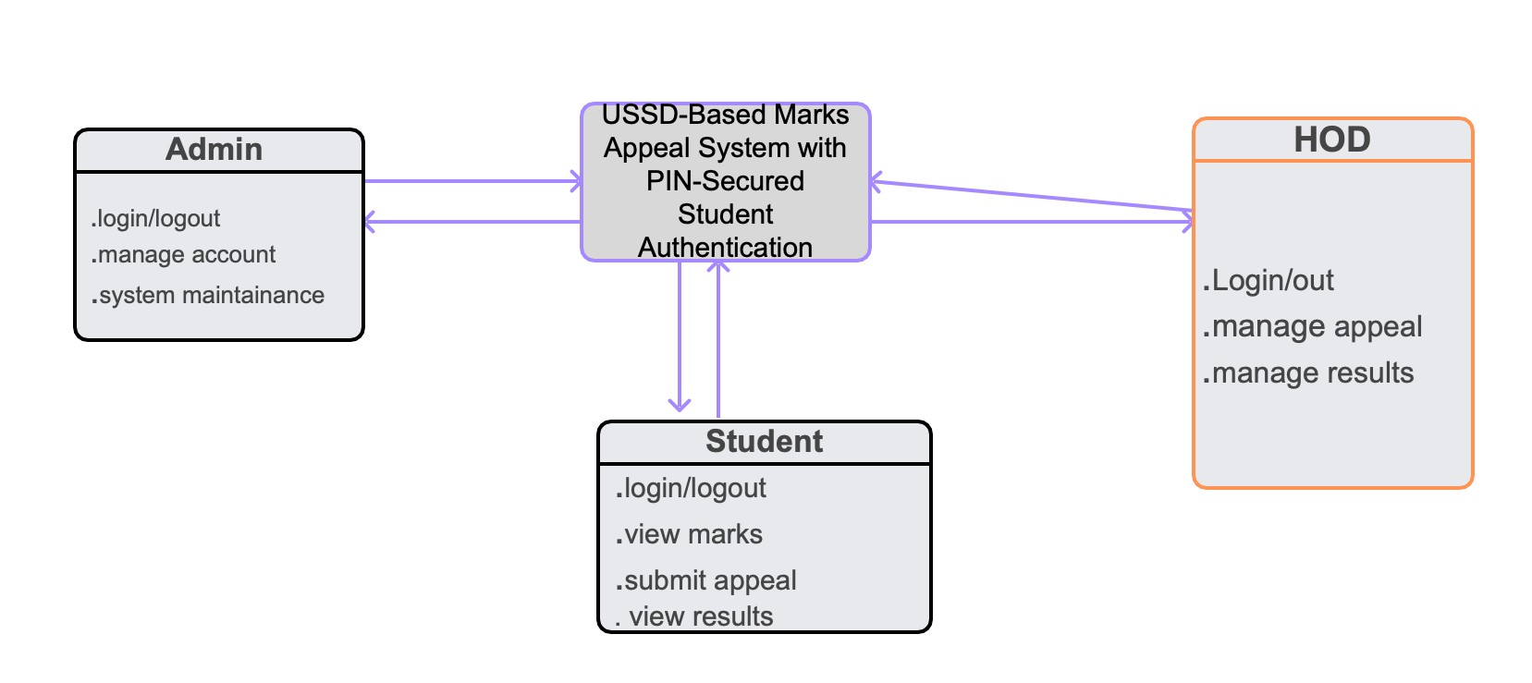
Figure 1: Conceptual Framework of the USSD-Based Marks Appeal System with PIN Security
Accessibility: USSD technology ensures that every student with a GSM-capable mobile phone can access the system, regardless of whether they own a smartphone, have a data subscription, or live in an area with internet connectivity. This pillar is supported by the empirical findings of Mtebe and Raisamo (2014) and the ITU (2021) data on mobile penetration in Africa.
Security: The PIN authentication mechanism, SHA-256 hashing, 3-strike lockout policy, OTP reset capability, and access audit trail collectively ensure that only the legitimate student can access or act on their academic records. This pillar is grounded in the CIA security triad (Stallings, 2017) and the PIN security design principles of Mas and Radcliffe (2010).
Transparency: Real-time appeal status tracking (Pending, Approved, Rejected) and a comprehensive access audit log provide students and administrators with full visibility into the state and history of every appeal. This pillar responds directly to the finding of Oyelaran and Tella (2018) that uncertainty about appeal status is the primary source of student frustration.
Efficiency: The centralized web administration portal consolidates all appeal records in a single, searchable interface, enabling administrators to review and resolve appeals with a single click, eliminating paper records and reducing average resolution time. This pillar is supported by Farhan and Razmak's (2019) finding that digital portals reduce processing time by an average of 60%.

CHAPETER THREE: RESEARCH METHODOLOGY

3.0 Introduction
This chapter describes the methodological approach adopted in this study. It details the research design, the population and sampling strategy, the data collection instruments, the data collection procedures, the data presentation and analysis techniques, and the measures taken to ensure validity, reliability, and ethical compliance. The methodology is designed to address each of the six specific objectives stated in Chapter One.

3.1 Research Design
This study adopts an applied research design underpinned by the Design Science Research (DSR) methodology (Hevner et al., 2004). DSR is appropriate for this study because the primary purpose is not to describe or explain an existing phenomenon, but to create and evaluate an innovative information system artefact the USSD-based marks appeal system with PIN authentication that solves a clearly identified real-world problem. DSR explicitly guides researchers to demonstrate that the artefact solves the problem (utility), is built on sound knowledge (rigour), and contributes generalizable knowledge to the research community (contribution).
A mixed-methods approach is employed for the evaluation phase: quantitative data from closed ended surveys and system performance metrics are complemented by qualitative data from semi structured interviews and open-ended survey responses. This triangulation strengthens the validity of the evaluation findings.
The system development follows the Agile Software Development methodology, specifically an iterative and incremental approach organized into six sprints. Agile is appropriate because it accommodates evolving requirements, delivers working software incrementally for early feedback, and enables continuous testing throughout the development process.

3.2 Population and Selection of the Sample

3.2.1. Population
The study population consists of two groups at the University of Kigali: (a) undergraduate students who have experienced or are likely to experience the marks appeal process, and (b) academic and administrative staff responsible for processing marks appeals. The total student population of the University of Kigali is estimated at approximately 5,000 students across all faculties.

3.2.2. Sample and Sampling Techniques
The sampling techniques in this study are stratified random sampling methods. The stratified random sampling was used because the population was not homogeneous and combining both stratified and simple random sampling methods. Therefore, the rationale for the use of this stratified random variable was used to reduce sampling errors because the elements(respondents) within each stratum are as homogenous as possible.
This technique enables the researcher to collect data, analyze it and interpret it according to the strata. A purposive sampling technique was used since it enabled the research to pick respondents who best meet the purpose of the study especially the members from IT and Playground management.
According to Slain, he has mentioned that if population is approximately equal to sample size, it could be good to use population instead of using sample size. As a researcher I chose to use sample size instead of population.

Sample size
Sample size is a count of individual samples or observations in any statistical setting, such as a scientific experiment or a public opinion survey. Though a relatively straightforward concept, choice of sample size is a critical determination for a project. Too small a sample yields unreliable
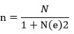
According to Yamane This formula will be used to calculate the sample sizes, Which n= sample size, N= population size, and e=level of precision (0.05).
Respondents | population | Sample size
Students | 5380 | 372
Deans and hod | 20 | 19
total | 5400 | 391
Table 1: population
When the population is small (usually below 100), the best approach is to include all members of the population in your study. This is called: Census Method / Total Population Sampling.

3.3 Tools for data collection / Instrumentation
In my study on USSD-Based Marks Appeal System with PIN-Secured Student Authentication, several data collection tools can be used to gather accurate and reliable information from respondents and performance activities.

3.3.1. Questionnaires
Questionnaires are structured sets of written questions used to collect data from respondents such as players, coaches, and staff. They can include both closed-ended and open-ended questions. I will use in my study Collect data on current marks appeal challenges, Gather student opinions on USSD accessibility, Measure satisfaction with the existing manual process

3.3.2. Interviews
Interviews involve direct communication between the researcher and respondents (face-to-face or online). I will use in my study to Get detailed views from academic staff and HODs, Understand the appeal review decision-making process, Explore challenges of the current manual appeals system 3.3.3. Observation
Observation involves watching and recording activities in real-life situations without interfering. I will use this tool in my study to Observe what is going on Study how performance is currently analyzed, Identify gaps in manual analysis methods

3.3.4. Document Review (Secondary Data)
This involves analyzing existing documents such as reports, match statistics, and performance records. I will Use this tool in my study to Review student academic records and existing appeal forms, Analyze previous appeal processing timelines

3.4 Collection of data
The data collection for this study will combine primary and secondary sources to ensure comprehensive and reliable information on USSD-Based Marks Appeal System with PIN-
Secured Student Authentication at ULK. Primary data will be collected through, and analysts to gather information on current performance evaluation methods, perceptions of AI analytics, and challenges in decision-making. Interviews with coaches and technical staff will provide detailed insights into tactical decisions, training strategies, and potential adoption of AI-based systems, while observations of training sessions and matches will capture real-time performance evaluation practices. Secondary data will include existing performance records, match statistics, and video recordings to supplement primary data and provide a historical perspective on team performance. By combining these tools, the study will generate both qualitative and quantitative data necessary to assess the effectiveness of Usage of USSD in marks appeal and identify areas for improvement in ULK.

3.5 Data Collection Tools

3.5.1. Software Engineering Methods

3.5.1.1 Waterfall model
According to the proposed project I have decided to use waterfall model because it was help me in implementation of my project.
The waterfall model is sequential software development process, in which progress is seen as steadily downwards. As this model emphasizes planning in early stages, it ensures design flaws before they develop. In addition, its intensive document and planning make it work well for projects in which quality control is a major concern.
The following is the graphical representation of modified waterfall model according to my system and their different phases.
I.
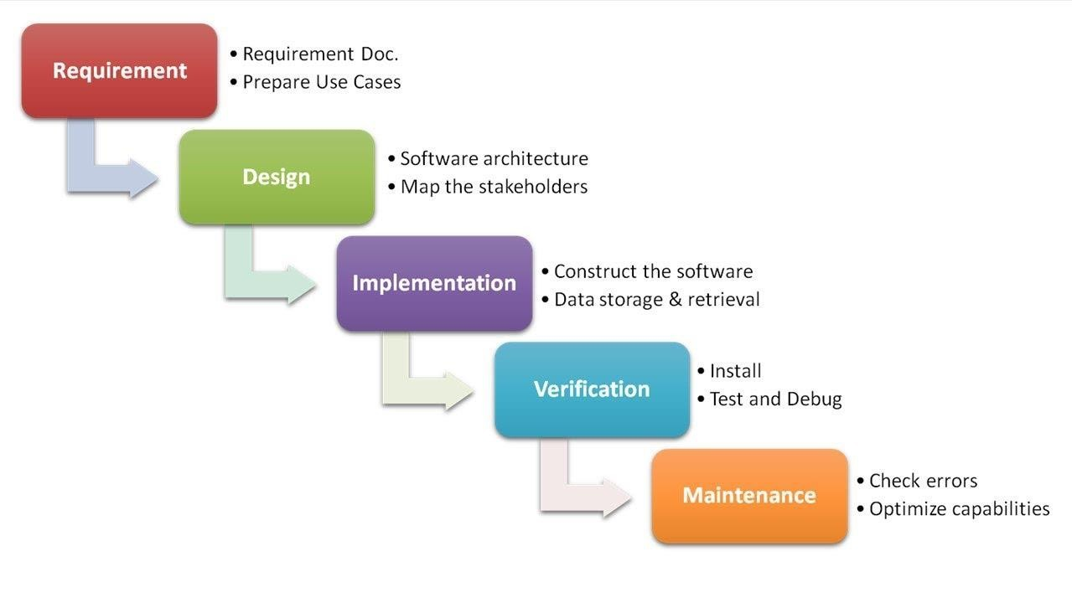
Figure 2: Waterfall model

Source: Pal Kienitz, 2017
Below here is what was done in each phase:
- Requirement Specifications Phase: during this first phase data have been collected from administration, other staff members and Subscribers.
- Analysis and Design Phase: The information collected was analyzed to help in the design and implementation of mulberry and survey management information system.
- Implementation Phase: after analyzing all information, understanding and designing previous two phases, this phase started with coding for the system.
- Testing and Maintenance: after the codes were written, they were tested for their outputs and removal of errors was conducted as well.

3.6 Validity and Reliability

3.6.1. Validity
Validity refers to the accuracy and truthfulness of the data collected in representing what the study intends to measure. In this research on the USSD-Based Marks Appeal System with PIN-Secured Student Authentication at ULK, validity was ensured in the following ways.
Content Validity: The questionnaires and interview guides were designed based on existing literature, the specific research objectives, and the identified gaps in the current marks appeal process. All questions were structured to cover the key aspects of the study, including student accessibility to the appeal system, the effectiveness of PIN-secured authentication, the usability of the USSD interface, and the efficiency of the web-based administration portal.
Construct Validity: The research instruments were designed to measure the intended constructs of the study, specifically student appeal experience, perceived ease of use of the USSD interface, security effectiveness of the PIN authentication mechanism, and administrative efficiency in managing appeal records. Each question was aligned with a specific research objective to ensure that the instruments accurately reflect the constructs under investigation.
Face Validity: The research instruments were reviewed by IT experts, academic staff, and lecturers in the Department of Information Technology at the University of Kigali to ensure clarity, relevance, and comprehensibility. Feedback received during this review was used to refine ambiguous questions before the instruments were administered to respondents.
By applying these measures, the study ensured that the collected data accurately represents the marks appeal management processes at ULK and provides a valid basis for the design and evaluation of the proposed system.

3.6.2. Reliability
Reliability refers to the consistency and dependability of the research instruments in producing similar results under the same conditions. For this study, reliability was ensured through the following measures.
Pilot Testing: The questionnaires and interview questions were pre-tested on a small group of ten students and two administrative staff members not included in the main study. This pilot test was used to identify ambiguous questions, estimate the time required for completion, and refine the instruments before full administration.
Internal Consistency: Responses to related questions within the same instrument were checked for consistency to confirm that the instruments reliably measure the same constructs. Items addressing similar dimensions of the marks appeal process, such as accessibility, security, and processing time, were cross-checked against each other to detect and resolve contradictions.
Standardized Procedures: All data collection activities, including questionnaire administration, interviews, and observation sessions, followed standardized steps to minimize variation and reduce potential bias. Each respondent received the same instructions and was given equivalent time to complete the instruments.
Ensuring reliability in this way produced dependable data that can be used to accurately analyse the role of the USSD-Based Marks Appeal System in improving academic service delivery at ULK, and to draw meaningful conclusions regarding the security, usability, and operational effectiveness of the proposed system.

3.7 Ethical Considerations
Ethical considerations are crucial to ensure that this study on the USSD-Based Marks Appeal System with PIN-Secured Student Authentication at ULK was conducted responsibly and with full respect for all participants. The following ethical principles were observed throughout the research process.
Informed Consent: All participants, including students, academic staff, and Heads of Department (HODs), were fully informed about the purpose of the study, the nature of their involvement, the types of questions they would be asked, and how the data collected would be used. Written or verbal consent was obtained from every participant before any data collection activity was conducted.
Confidentiality and Privacy: All personal information provided by participants, including student registration details, staff designations, and individual responses, was treated as strictly confidential. Data was anonymized wherever necessary, and only the researcher and the supervising lecturer had access to the raw data. No individual respondent was identified by name in the findings or analysis of this study.
Voluntary Participation: Participation in the study was entirely voluntary. All students, academic staff, and HODs were informed of their right to withdraw from the study at any time without facing any academic, professional, or institutional consequences. No pressure or incentive was applied to encourage participation.
Data Security: All collected data, including completed questionnaires, interview notes, and system testing records, were securely stored in password-protected digital files. Physical copies of instruments were kept in a secure location accessible only to the researcher. All data will be disposed of responsibly upon completion of the study.
Avoiding Harm: The study was designed to ensure that no physical, psychological, or social harm came to any participant. The data collected was used solely to improve the marks appeal process at ULK and to contribute to academic knowledge in the field of mobile-based information systems. No data was used to negatively evaluate, penalize, or unfairly assess students or members of staff.
Integrity and Honesty: The researcher maintained full transparency in all stages of data collection, analysis, and reporting. All findings are presented accurately and without fabrication, selective omission, or bias. Any limitations encountered during data collection are disclosed honestly in the relevant sections of this study.

CHAPTER IV: SYSTEM ANALYSIS, DESIGN AND IMPLEMENTATION

4.1 Introduction
This chapter presents the comprehensive system analysis, design, and implementation of the USSD-Based Marks Appeal System with PIN-Secured Student Authentication developed as a case study of University Libre de Kigali (ULK). The chapter begins by presenting and interpreting the data collected during the research phase, then identifies the needs of the proposed system based on research findings. It proceeds to describe the limitations of the existing manual system and provides a detailed description of the new system including its functional modules, hardware and software requirements, and non-functional characteristics. The chapter further illustrates the new system through diagrams including Data Flow Diagrams, Use Case and Sequence Diagrams, database normalization, Data Dictionary, Entity Relationship Diagram, and Physical Data Model. The architecture of the front-end is then presented, followed by implementation details including tools used, source code excerpts, and screenshots. The chapter concludes with a structured testing section covering unit, validation, integration, functional, and acceptance testing.

4.2 Data Analysis and Presentation
Data were collected from two primary groups: undergraduate students and academic/administrative staff at ULK. A total of 391 respondents participated: 372 students and 19 Deans and Heads of Department (HODs), selected using stratified random sampling and census methods respectively.

4.2.1 Student Survey Results
A structured questionnaire was administered to 372 students. The key findings are presented below.
Question | Response | Count | Percentage
Q1: Aware of marks appeal process? | Yes | 289 | 77.7%
 | No | 83 | 22.3%
Q2: Have you submitted an appeal? | Yes | 198 | 53.2%
 | No | 174 | 46.8%
Q3: Time for appeal resolution? | Less than 1 week | 12 | 6.1%
 | 1-2 weeks | 43 | 21.7%
 | 2-4 weeks | 89 | 44.9%
 | More than 4 weeks | 54 | 27.3%
Q4: Informed of status in real time? | Yes | 47 | 23.7%
 | No | 151 | 76.3%
Q5:OwnUSSD-capable phone? | Yes | 361 | 97.0%
 | No | 11 | 3.0%
Q6: Prefer USSD-based appeal system? | Yes | 334 | 89.8%
 | Neutral | 27 | 7.3%
 | No | 11 | 2.9%
Table 2: Student Survey Results

4.2.2 Administrative Staff Survey Results
Interviews and questionnaires were administered to 19 Deans and HODs. The key findings are summarized below.
Question | Response | Count | Percentage
Q1: How are appeals currently managed? | Paper-based forms only | 11 | 57.9%
 | Paper-based with email follow-up | 6 | 31.6%
 | Digital system | 2 | 10.5%
Q2: Average appeals per semester? | Less than 10 | 4 | 21.1%
 | 10-30 | 9 | 47.4%
 | More than 30 | 6 | 31.5%
Q3: Biggest challenges? | Misplaced or lost documents | 16 | 84.2%
 | Delayed responses to students | 18 | 94.7%
 | No central record of appeals | 17 | 89.5%
 | No student identity authentication | 14 | 73.7%
Q4: Would a web dashboard help? | Strongly agree | 14 | 73.7%
 | Agree | 4 | 21.1%
 | Neutral | 1 | 5.3%
Table 3: Administrative Staff Survey Results

4.3 Interpretation of Findings
The survey data reveals several critical insights that directly justify the design decisions of the proposed system.
The finding that 76.3% of students were never informed of their appeal status in real time confirms Oyelaran and Tella's (2018) observation that uncertainty about appeal status is the primary source of student frustration. This finding directly motivates the real-time appeal status tracking feature of the proposed system, which allows students to check the status (Pending, Approved, or Rejected) of their appeal at any time via USSD.
The finding that 44.9% of students waited between two and four weeks for appeal resolution, and 27.3% waited longer than four weeks, highlights severe inefficiency in the current process. A centralized web dashboard with one-click status updates, as implemented in the proposed system, is expected to reduce this resolution time significantly, consistent with Farhan and Razmak's (2019) finding that digital portals reduce processing time by an average of 60%.
The finding that 97.0% of students own a USSD-capable mobile phone strongly validates the choice of USSD as the primary student interface. This is consistent with Mtebe and Raisamo's (2014) finding that USSD is the preferred digital service channel for East African university students.
The finding that 84.2% of administrative staff reported problems with misplaced or lost documentation, and 89.5% noted the absence of a central appeals record, confirms the need for a centralized, persistent database-backed system. The proposed system's seven-table relational database directly addresses these gaps.
The finding that 73.7% of administrative staff identified the absence of student identity authentication as a challenge confirms the need for the PIN-secured authentication mechanism, which is the original security contribution of this study.

4.4 Summary of Findings: Needs of the Proposed System
Based on the research findings presented above, the following requirements for the proposed system were identified:
- Secure Student Authentication: The system must authenticate students using a 4-digit PIN that is hashed using SHA-256 before storage, ensuring that only authorized students can access their marks and submit appeals. A 3-strike lockout policy and OTP-based PIN reset via Africa's Talking SMS API must be implemented.
- USSD-Based Student Interface: The system must enable students to interact via USSD on any GSM mobile phone, without requiring internet connectivity, a smartphone, or a data subscription. This ensures universal accessibility for all students at ULK.
- Marks Viewing: Authenticated students must be able to view their recorded marks for all enrolled modules within a single USSD session.
- Appeal Submission: Students must be able to select a specific module, enter a reason for appeal, and submit the appeal through the USSD interface. Submitted appeals must be persisted in the database with a default status of "Pending".
- Real-Time Appeal Status Tracking: Students must be able to check the current status of their most recent appeal (Pending, Approved, or Rejected) via USSD at any time.
- Administrator Web Portal: Academic and administrative staff must be able to log in to a secure web portal, view all submitted appeals in a centralized dashboard, and update appeal statuses using a single action.
- Audit Trail: The system must maintain a full audit log of all USSD access events, including the student ID, action performed, outcome, phone number, and timestamp.

4.5 Description of the Existing System
The existing marks appeal process at University Libre de Kigali (ULK) is primarily manual and paper based. When a student believes that their recorded mark for a module is incorrect, they are required to visit the faculty office or academic registry in person during working hours to collect a paper appeal form. The student completes the form manually, stating the module name, the recorded mark, and the reason for the appeal. The completed form is submitted to a faculty officer or deposited in a submission tray at the department office.
The submitted forms are then reviewed manually by the relevant lecturer or examination committee. The review process involves physically retrieving the student's examination script, cross-checking it against the marks register, and preparing a written response. This process is handled on a first-come, first-served basis and is subject to the availability of academic staff, which can be constrained by teaching schedules and examination periods.
Feedback is communicated to students through notice boards, departmental email, or direct verbal communication. There is no systematic mechanism for notifying students when their appeal has been received, when it is under review, or when a decision has been made.
The key weaknesses of the existing system are as follows:
- No real-time status tracking: Students have no visibility into the progress of their appeal after submission, leading to repeated physical visits to the department office.
- No authentication: Any student or third party can submit a form on behalf of another student, as there is no mechanism to verify the identity of the person submitting the appeal.
- Risk of lost documentation: Paper forms can be misplaced, damaged, or destroyed, creating disputes over whether an appeal was ever submitted.
- Limited accessibility: Students who are off-campus, ill, or have mobility challenges cannot access the appeal process without physically visiting the institution.
- No centralized records: Different departments maintain independent, informal records of appeals, making it impossible for senior administration to obtain an institution-wide view of appeal volumes and outcomes.
- Slow resolution times: The manual review process and absence of escalation mechanisms result in appeal resolution times ranging from two to six weeks.
- No audit trail: There is no mechanism for tracking who accessed or modified an appeal record, creating accountability gaps.

4.6 Description of the New System

4.6.1 Modules and Functional Description
The proposed USSD-Based Marks Appeal System with PIN-Secured Student Authentication comprises three functional modules, corresponding to the three system actors: Student (USSD), Administrator (Web Portal), and Head of Department (Web Portal).
Module 1: Student USSD Module
This module is the primary student-facing interface. It is accessible by dialling a USSD short code from any GSM mobile phone. The module implements the following sub-functions:
- PIN Registration: On first access, a new student is prompted to create a 4-digit PIN. The PIN is confirmed through a re-entry step and then stored as a SHA-256 hash in the pin_credentials table. The plaintext PIN is never stored.
- PIN Authentication: On all subsequent sessions, the student is required to enter their student ID and PIN. The entered PIN is hashed and compared against the stored hash. If three consecutive incorrect entries are made, the account is locked.
- PIN Reset via OTP: A locked student can request a PIN reset. A 6-digit OTP is generated, sent to the student's registered phone number via the Africa's Talking SMS API, and the student is prompted to enter the OTP within 10 minutes to unlock the account and set a new PIN.
- Marks Viewing: An authenticated student can select "Check my marks" to retrieve and display all recorded module marks from the marks table for their student ID.
- Appeal Submission: An authenticated student can select "Appeal my marks", choose the specific module to appeal, enter a reason (up to the USSD character limit), and submit the appeal. The appeal is inserted into the appeals table with a status of "Pending".
- Appeal Status Checking: An authenticated student can check the current status of their most recent appeal, which is retrieved from the appeals table joined with the appeal_status table.
Module 2: Administrator Web Portal Module
This module is accessible via a web browser at the system's admin URL. It implements the following sub-functions:
- Admin Login: The administrator enters a username and password. The password is hashed using SHA-256 and compared against the stored hash in the admins table. On successful authentication, a server-side session is created.
- Appeals Dashboard: The administrator views all submitted appeals in a tabular format, sorted by submission date. Each row displays the student ID, module name, reason, current status, and action controls.
- Status Management: The administrator can update the status of any appeal to "Approved" or "Rejected" using a dropdown and submit button. The change is committed to the database immediately.
- Audit Log Review: The administrator can view the access_audit table to review all USSD authentication events, including student ID, phone number, timestamp, and success/failure status.
- Logout: The administrator can securely terminate their session.
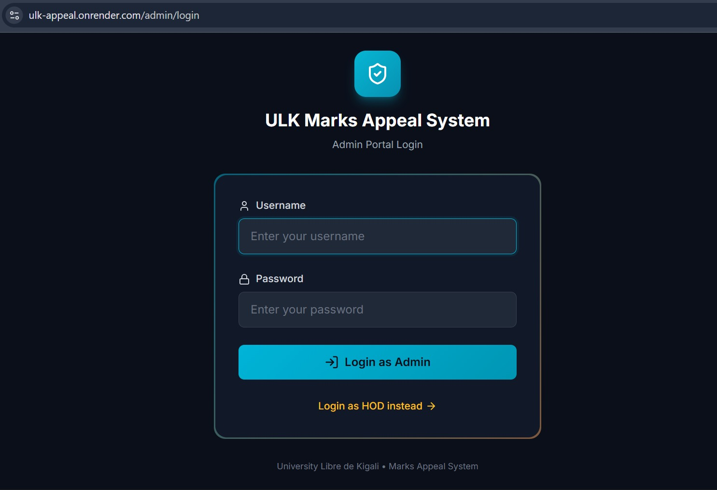
Figure 3admin login page
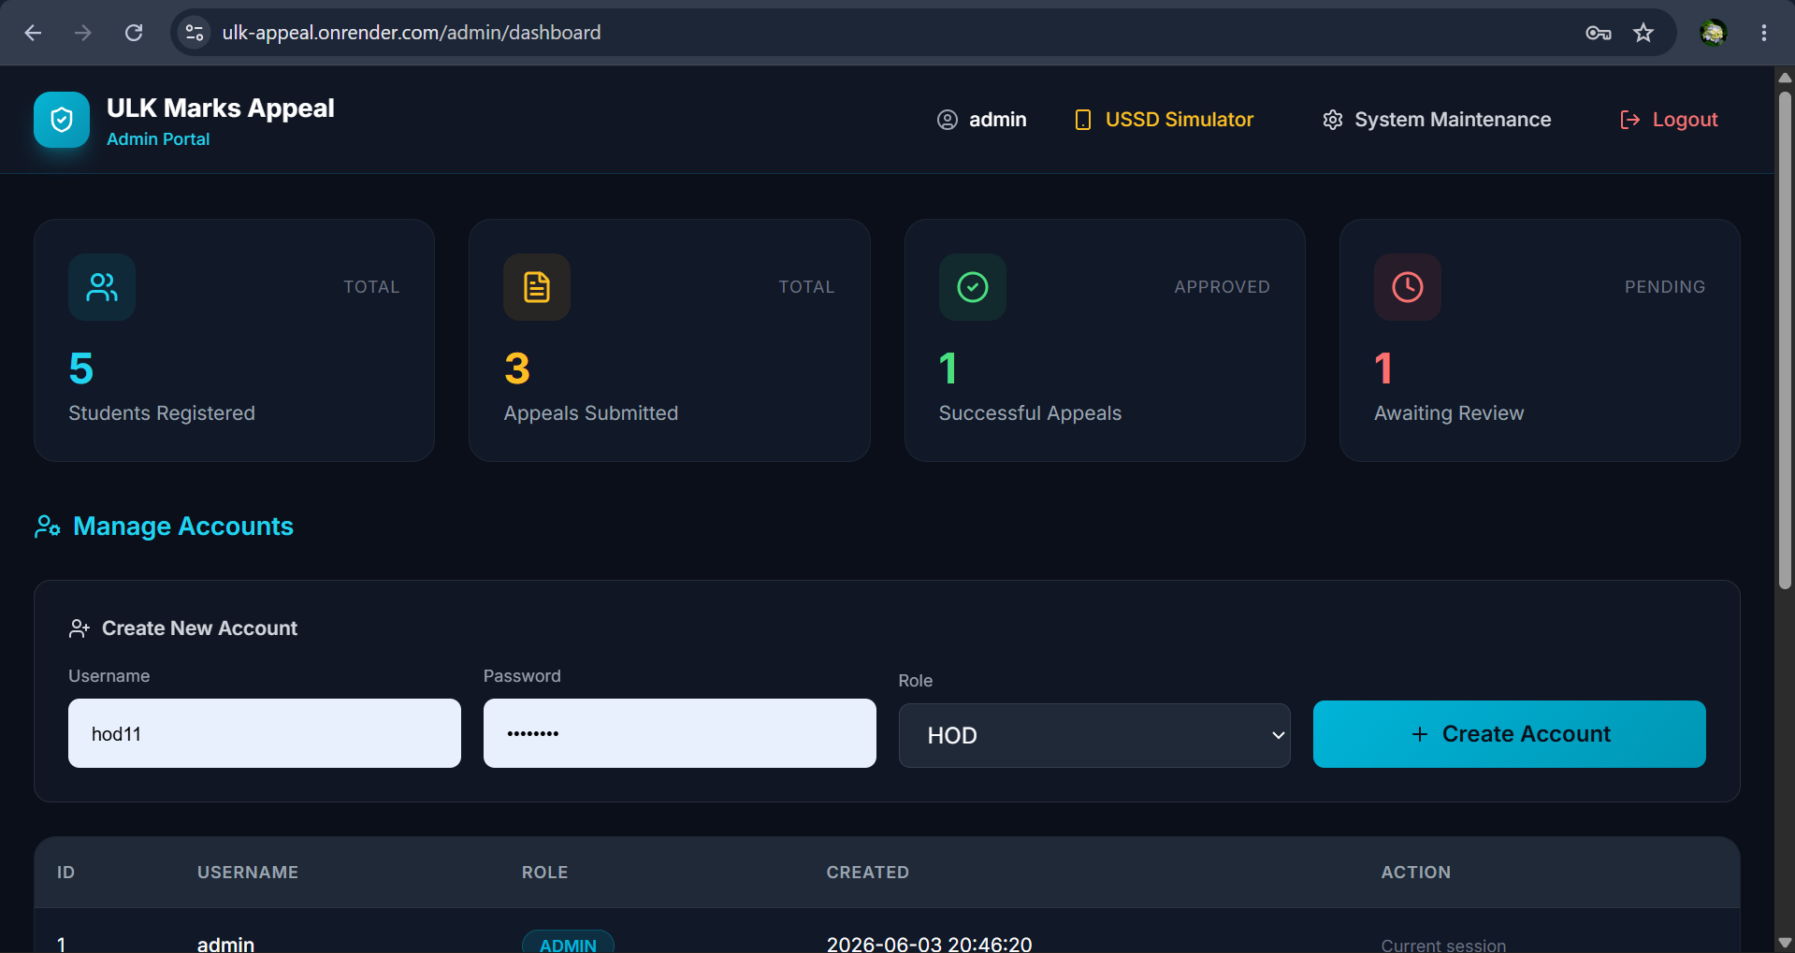
Figure 4admin dashboard
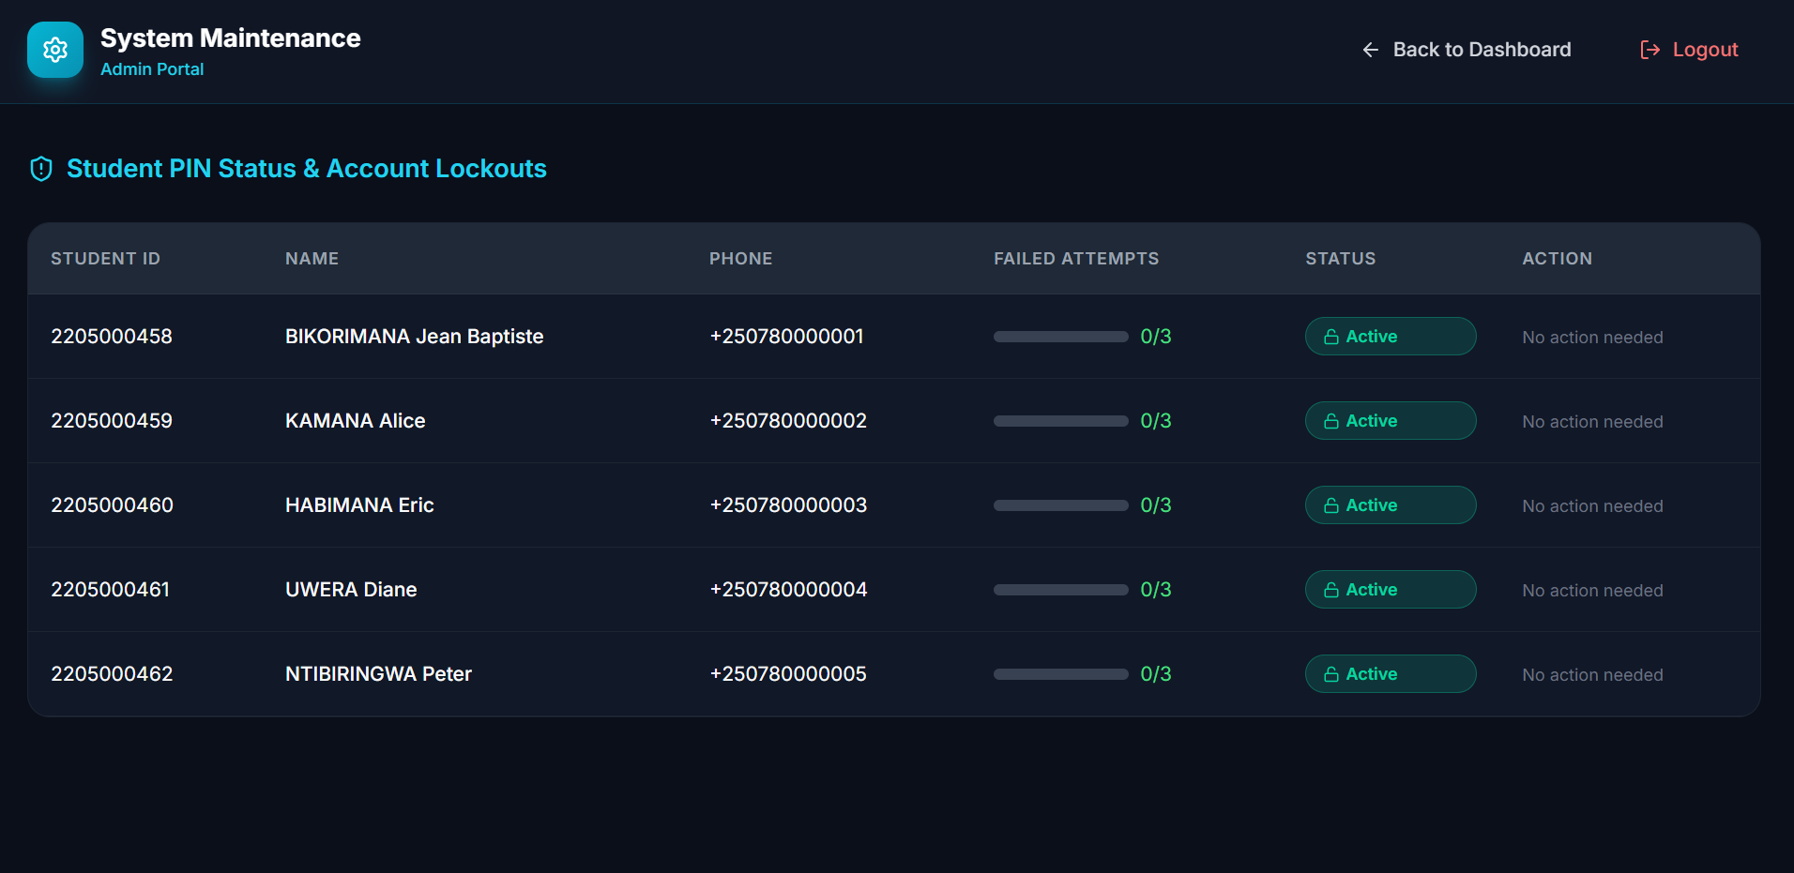
Figure 5 admin System Maintenance
Module 3: Head of Department (HOD) Web Portal Module
This module provides the HOD with read and review access to appeals relevant to their department.
- HOD Login: The HOD authenticates using a username and SHA-256-hashed password stored in the hod_accounts table.
- Department Appeals View: The HOD views all appeals submitted by students in their department, filtered by department code.
- Recommendation Submission: The HOD can add a recommendation or comment to an appeal, which is stored in the appeals table for the administrator's consideration.
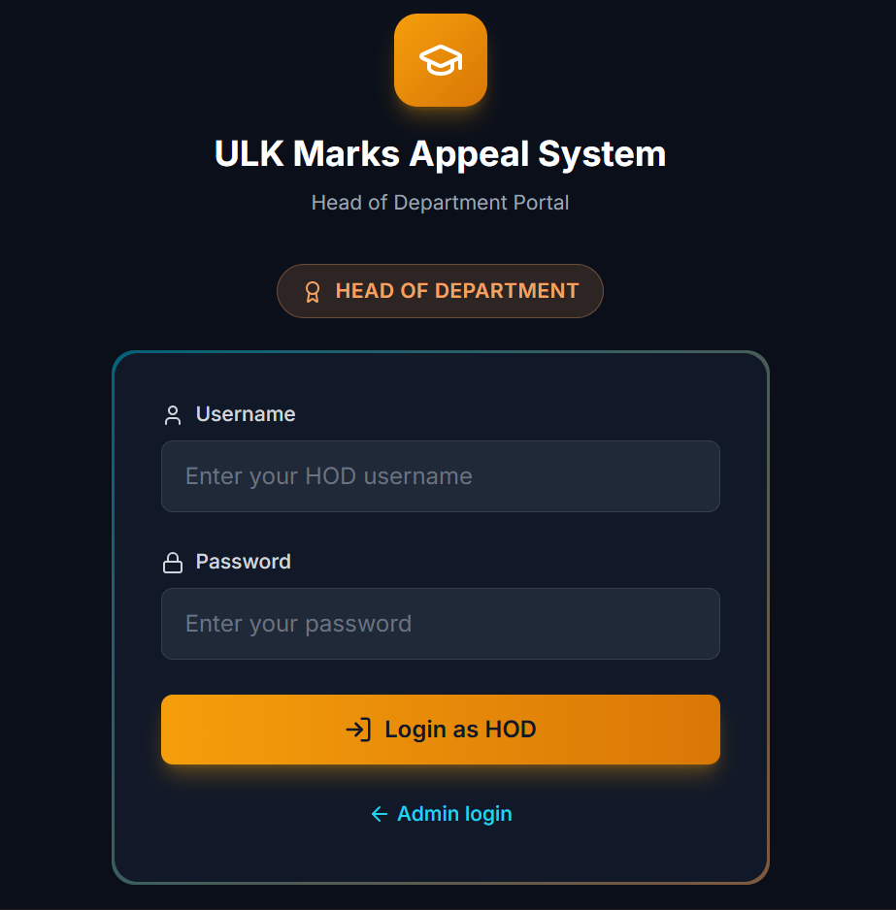
Figure 6: HOD login
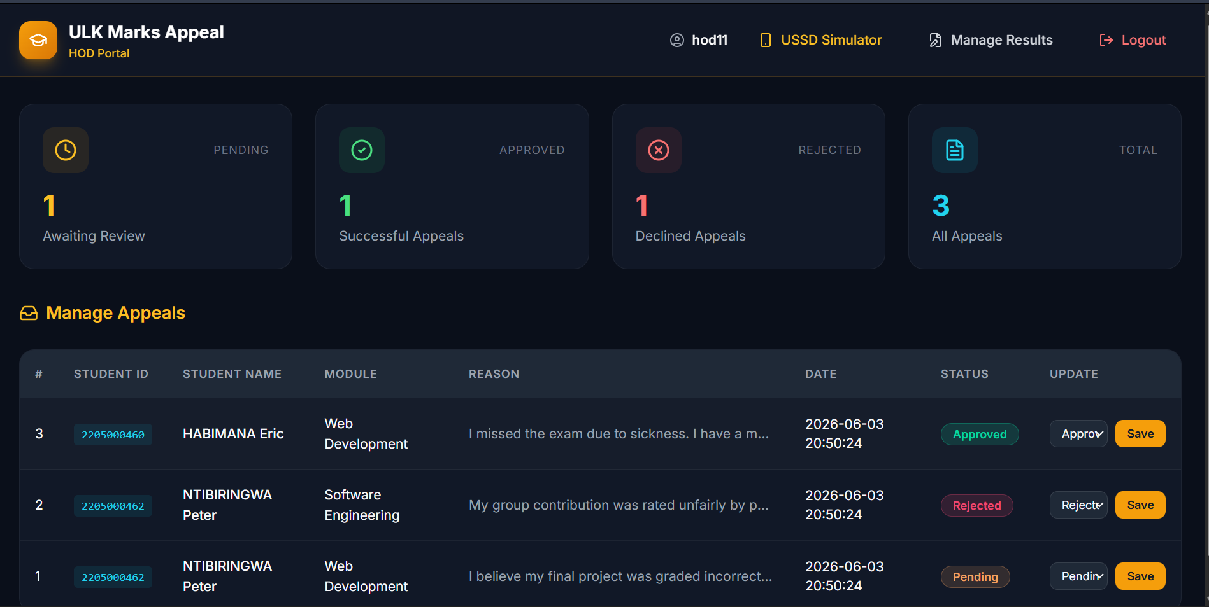
Figure 7 HOD Dashboard
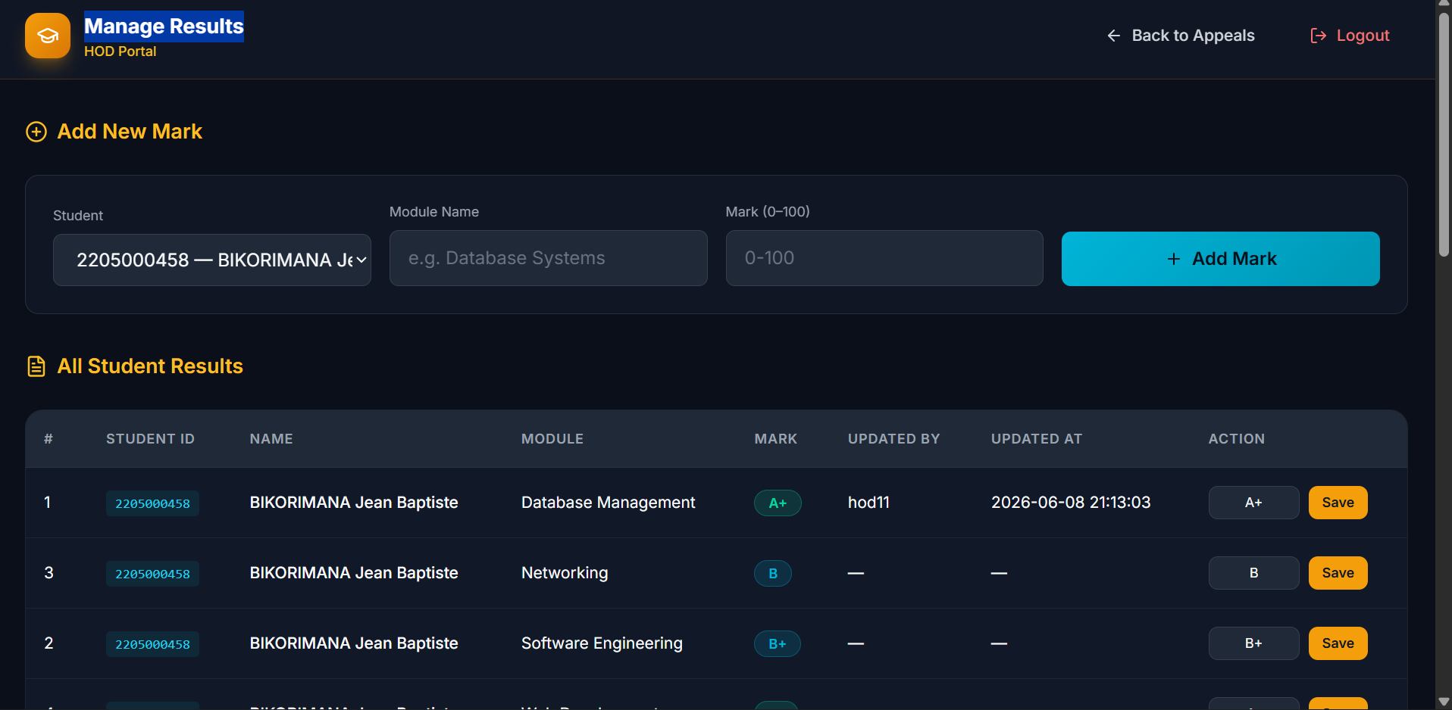
Figure 8 HOD Manage Results

4.6.2 System Configuration: Hardware and Software Requirements
Hardware Requirements
Server Side:
- Processor: Minimum dual-core 2.0 GHz (quad-core recommended)
- RAM: Minimum 2 GB (4 GB recommended for concurrent USSD sessions)
- Storage: Minimum 20 GB SSD
- Network: Stable internet connection with a public IP address or domain name for Africa's Talking callback registration
Client Side (Student):
- Any GSM mobile phone (feature phone or smartphone)
- Active SIM card on a network supported by Africa's Talking USSD
Client Side (Admin/HOD):
- Any computer, tablet, or smartphone with a modern web browser
- Internet connectivity
Software Requirements
Server Side:
- Operating System: Ubuntu 22.04 LTS (recommended) or any Linux distribution
- Python 3.10 or higher
- Flask 2.x web framework
- MySQL 8.0 database server
- Africa's Talking USSD and SMS SDK
- Web server: Render.com (cloud deployment) or Nginx/Gunicorn for on-premise
Client Side:
- No software installation required for students (USSD is network-level)
- Web browser (Chrome, Firefox, Edge) for Admin and HOD portals

4.6.3 Technology (Platform) to be Used
- Backend Language: Python 3.10 selected for its readability, extensive library ecosystem, and strong support for web and API development.
- Web Framework: Flask 2.x selected for its lightweight architecture, minimal overhead, and suitability for building USSD callback endpoints that must respond within Africa's Talking's 30-second session timeout.
- Database: MySQL 8.0 selected for its support of relational integrity, transactional consistency, and compatibility with Flask-MySQLdb.
- USSD/SMS Gateway: Africa's Talking API the leading USSD gateway in East Africa, used by M-Pesa and major fintech platforms.
- Password/PIN Hashing: SHA-256 (hashlib, Python standard library) NIST-recommended for credential storage.
- Frontend: HTML5, Bootstrap 5, Jinja2 templating for the responsive administrator and HOD web portals.
- Deployment Platform: Render.com provides a publicly accessible HTTPS callback URL required by Africa's Talking for USSD session delivery.
- Version Control: Git/GitHub for source code management throughout the development sprints.

4.6.4 Non-Functional Requirements
Security: All student PINs and administrator passwords are stored as SHA-256 cryptographic hashes. The system enforces a 3-strike lockout policy. OTP-based reset expires after 10 minutes. All web portal pages are protected by server-side session checks.
Performance: The USSD endpoint must return a response within 5 seconds to comply with Africa's Talking session timing requirements. Database queries use indexed fields (student_id, session_id) to ensure sub-second query performance under normal load.
Availability: The system must be available 24 hours per day, 7 days per week, as students may access USSD outside business hours. The USSD channel itself remains active as long as the host network is operational.
Scalability: The relational schema and Flask application are designed to support multiple concurrent USSD sessions using session-level state management. The cloud deployment platform allows vertical and horizontal scaling as demand increases.
Reliability: Session timeouts of 180 seconds are enforced at the application level to recover gracefully from abandoned USSD sessions. Database transactions use commit() explicitly to ensure data integrity.
Usability: The USSD menu is structured to a maximum of three levels deep to ensure compatibility with Africa's Talking's session character limits and to minimise cognitive load for students on small-screen feature phones.
Maintainability: The application follows the Model-View-Controller (MVC) pattern, separating database logic, Flask routes, and Jinja2 templates to facilitate future modification and extension.

4.7 Illustration of the New System

4.7.1 Data Flow Diagrams and Processes
Context Diagram (Level 0 DFD)
The Context Diagram shows the entire system as a single process and identifies the three external entities that interact with it. The central process is "USSD-Based Marks Appeal System". The Africa's Talking USSD Gateway acts as an intermediary channel between the Student entity and the system.
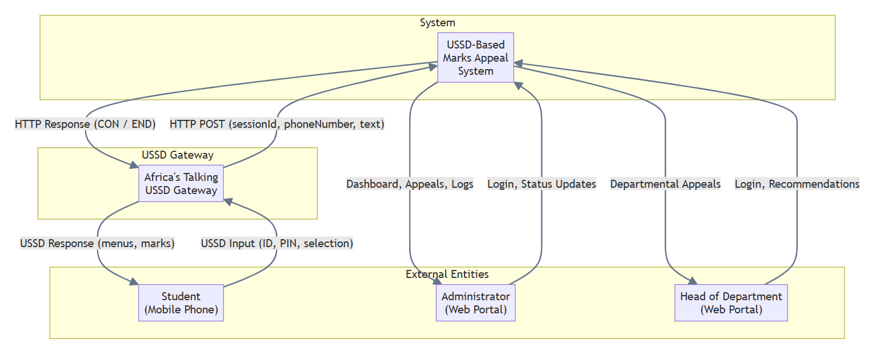
Figure 9Level 0 DFD
DFD Level 1
Five primary processes with their data stores: Authenticate Student, View Marks, Submit Appeal, Check Appeal Status, Manage Appeals.
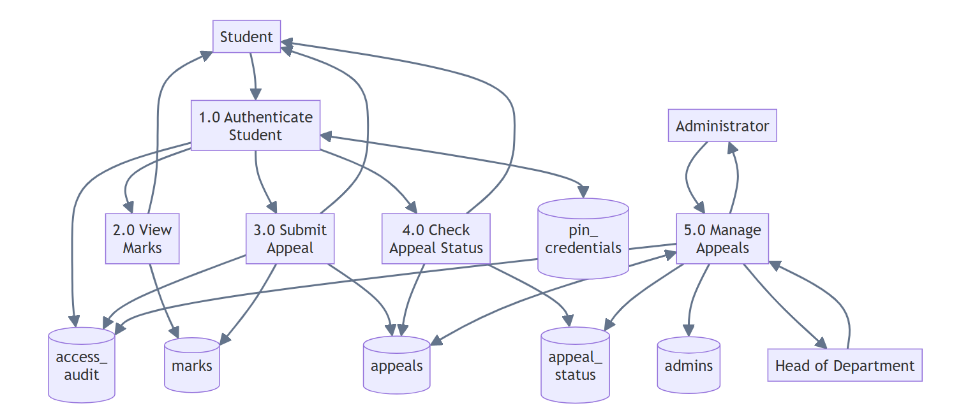
Figure 10:DFD Level 1 diagram
Process | Input | Data Stores | Output
Process 1: Authenticate Student | Student ID, PIN (from Student via USSD) | pin_credentials (read), access_audit (write) | Authentication result (success or failure prompt)
Process 2: View Marks | Authenticated student ID | marks (read) | Formatted marks list (to Student via USSD)
Process 3: Submit Appeal | Student ID, selected module name, appeal reason | marks (read), appeals (write) | Confirmation message (to Student via USSD)
Process 4: Check Appeal Status | Authenticated student ID | appeals, appeal_status (read) | Status message (Pending / Approved / Rejected)
Process 5: Manage Appeals (Admin/HOD) | Admin/HOD credentials, status update selection | appeals, appeal_status, access_audit (read/write) | Dashboard view, updated appeal status
Table 4: DFD Level 1 Process Descriptions
DFD Level 2 Process 1 Decomposition: Authenticate Student
Decomposition of Process 1.0 into six sub-processes: Receive Student ID, Receive PIN, Hash PIN, Compare Hash vs DB, Enforce Lockout Policy, Log Event.
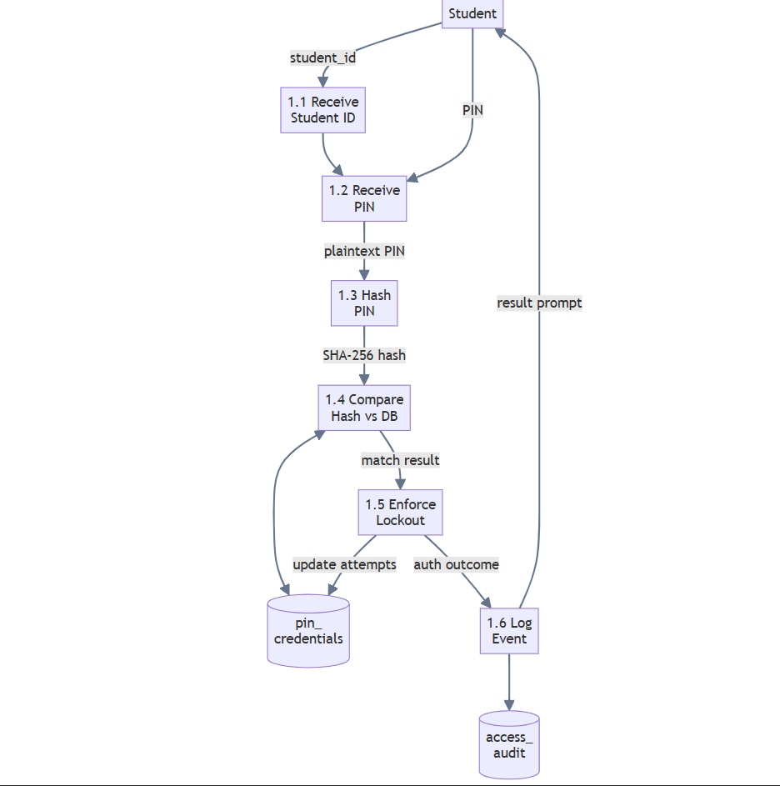
Figure 11Data Flow Diagram Level 2 (Authenticate Student)
Sub-Process | Input | Data Store | Output
Sub-process 1.1: Receive Student ID | USSD session text (step 1) |  | Student ID string
Sub-process 1.2: Request and Receive PIN | USSD session text (step 2) |  | Entered PIN string
Sub-process 1.3: Hash PIN | Entered PIN (plaintext) |  | 64-character SHA-256 hex digest
Sub-process 1.4: Compare Hash vs. DB | Student ID, hashed PIN | pin_credentials (read) | Match result (True/False)
Sub-process 1.5: Enforce Lockout Policy | Match result, failed_attempts count | pin_credentials (write) | Access granted or account locked
Sub-process 1.6: Log Authentication Event | Student ID, phone, status, timestamp | access_audit (write) | Audit record created
Table 5: DFD Level 2 Authentication Process Decomposition

4.7.2 Use Case and Sequence Diagrams
Use Case Diagram
The system has three actors and the following use cases:
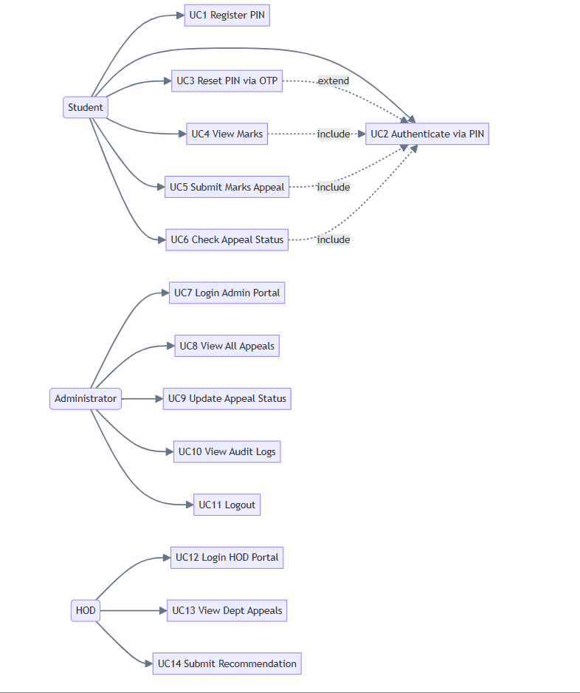
Figure 12 user case diagram
Relationships:
- UC4, UC5, and UC6 include UC2 (Authenticate via PIN) authentication is required before marks viewing, appeal submission, and status checking.
- UC3 extends UC2 triggered when is_locked = True after three failed PIN attempts.
- UC3 includes UC1 OTP reset restarts the PIN registration sub-flow.
Sequence Diagram 1: Student Submits an Appeal
The following sequence describes the complete interaction flow for the Submit Appeal use case:
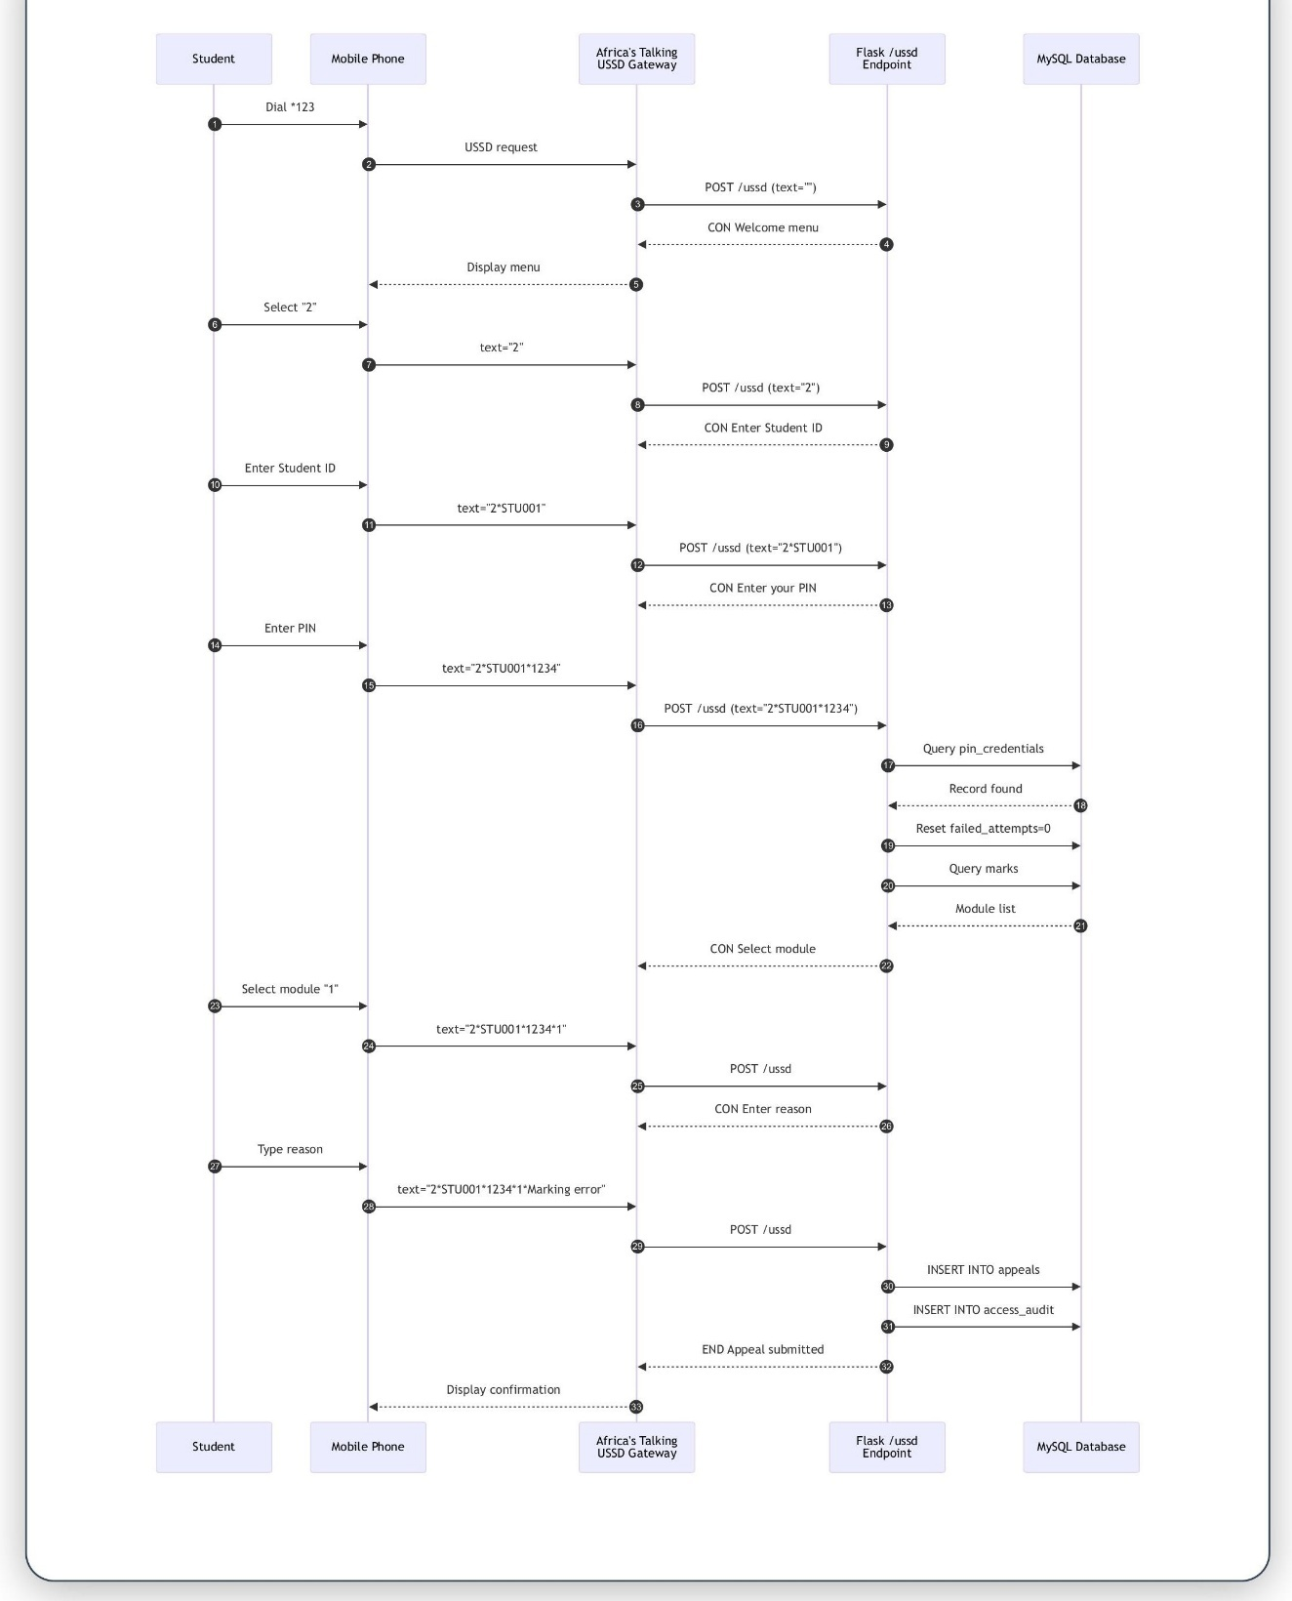
Figure 13: Sequence Diagram 1(Student Submits an Appeal)
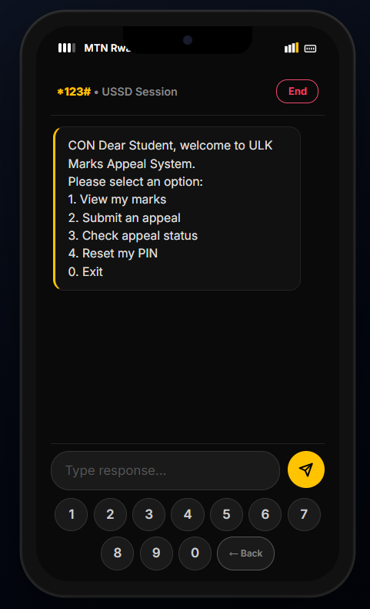

Figure 14 :Student USSD Portal
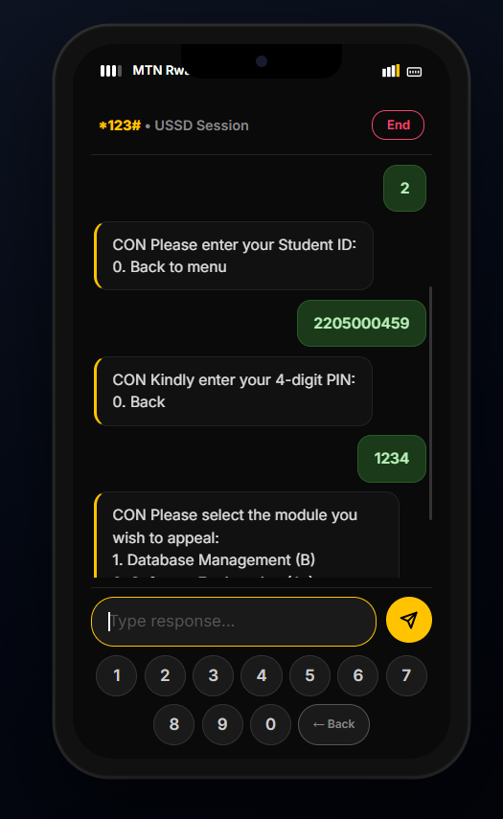
Figure 15Student USSD Portal 2
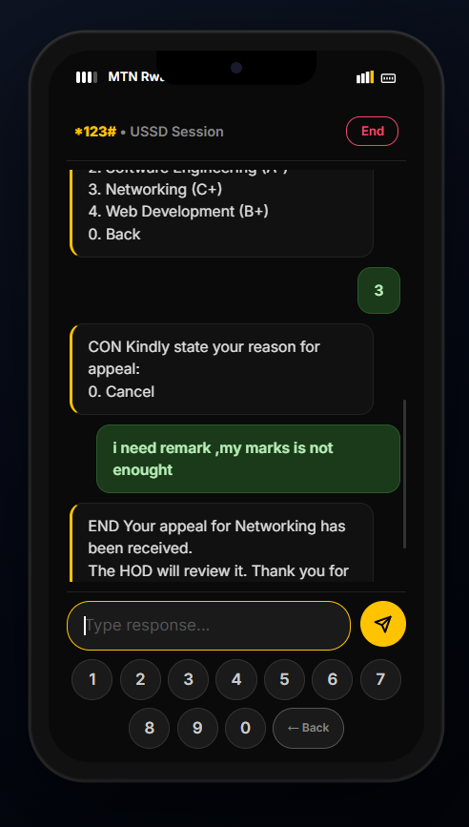
Figure 16 Submit Student USSD Portal
Sequence Diagram 2: Administrator Updates Appeal Status
- Admin opens browser and navigates to /admin/login.
- Browser sends GET request to Flask. Flask returns login HTML page.
- Admin enters username and password and submits form.
- Browser sends POST to /admin/login.
- Flask hashes password and queries admins table.
- Match found. Flask creates server session and redirects to /admin/dashboard.
- Flask queries appeals table (all records, ordered by date descending) and renders dashboard.
- Admin selects "Approved" for a specific appeal and clicks Update.
- Browser sends POST to /admin/update_status/<appeal_id>.
- Flask updates appeals table: SET status_id = 2 WHERE id = <appeal_id>.
- MySQL commits the transaction.
- Flask redirects to /admin/dashboard with flash message "Appeal status updated successfully."
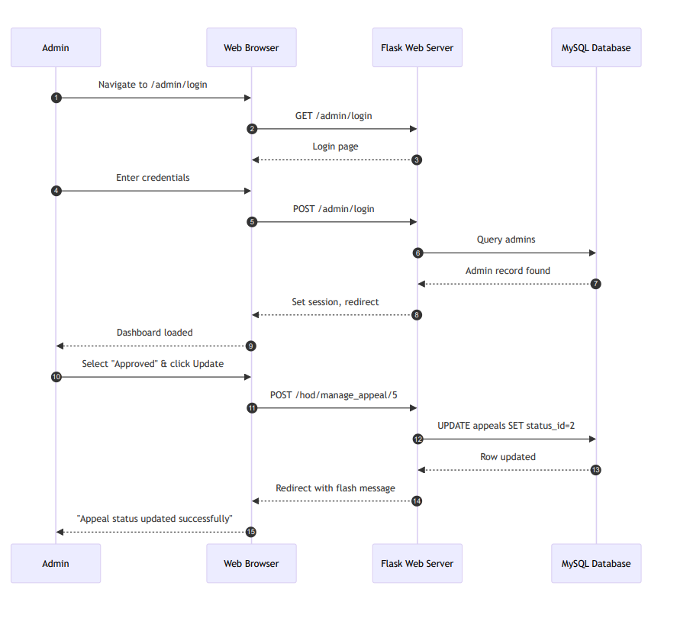
Figure 17:Sequence Diagram 2

4.7.3 Database Normalization
The database design follows the principles of relational normalization up to Third Normal Form (3NF) to eliminate data redundancy and ensure referential integrity.
First Normal Form (1NF): All tables contain only atomic (indivisible) values in each cell. No column stores multiple values or repeating groups. For example, the appeals table stores one module_name per row; if a student appeals multiple modules, each appeal is a separate row with a unique primary key.
Second Normal Form (2NF): All non-key attributes in each table are fully functionally dependent on the entire primary key. Since all tables use a single-column surrogate primary key (id, AUTO_INCREMENT), there are no partial dependencies.
Third Normal Form (3NF): All non-key attributes depend only on the primary key and not on other non-key attributes (no transitive dependencies). For example, the status name is stored in the separate appeal_status table and referenced by status_id in the appeals table, eliminating transitive dependencies.
Table Name | 1NF | 2NF | 3NF | Notes
students | Yes | Yes | Yes | Atomic fields; single PK
admins | Yes | Yes | Yes | Password stored as SHA-256 hash
marks | Yes | Yes | Yes | FK: student_id
appeal_status | Yes | Yes | Yes | Lookup table; eliminates redundancy
appeals | Yes | Yes | Yes | FK: student_id, status_id
pin_credentials | Yes | Yes | Yes | FK: student_id; PIN stored as hash
access_audit | Yes | Yes | Yes | FK: student_id
Table 6:Normalisation Summary

4.7.4 Data Dictionary
The following tables define all fields in the seven database tables of the system.
Field Name | Data Type | Constraints | Description
id | INT | AUTO_INCREMENT, PK | Unique identifier for each student record
student_id | VARCHAR(20) | NOT NULL, UNIQUE | Institutional student registration number
full_name | VARCHAR(100) | NOT NULL | Full name of the student
phone_number | VARCHAR(15) | NOT NULL | Registered mobile number for OTP delivery
department | VARCHAR(100) | NOT NULL | Department/faculty of the student
email | VARCHAR(100) | NULL | Student email address (optional)
created_at | TIMESTAMP | DEFAULT CURRENT_TIMESTAMP | Record creation date
Table 7:Data Dictionary students
Field Name | Data Type | Constraints | Description
id | INT | AUTO_INCREMENT, PK | Unique identifier for each admin account
username | VARCHAR(50) | NOT NULL, UNIQUE | Administrator login username
password | VARCHAR(255) | NOT NULL | SHA-256 hash of the administrator password
created_at | TIMESTAMP | DEFAULT CURRENT_TIMESTAMP | Account creation date
Table 8: Data Dictionary admins

Field Name | Data Type | Constraints | Description
id | INT | AUTO_INCREMENT, PK | Unique identifier for each marks record
student_id | VARCHAR(20) | NOT NULL, FK | Student registration number
module_name | VARCHAR(100) | NOT NULL | Name of the academic module
mark | INT | NOT NULL | Recorded mark for the module (0-100)
academic_year | VARCHAR(20) | NULL | Academic year (e.g., 2025/2026)
semester | VARCHAR(20) | NULL | Semester identifier (e.g., Semester 1)
Table 9:Data Dictionary marks

Field Name | Data Type | Constraints | Description
id | INT | AUTO_INCREMENT, PK | Unique identifier for each status record
status_name | VARCHAR(50) | NOT NULL | Status label: Pending, Approved, or Rejected
Table 10: Data Dictionary appeal_status
Field Name | Data Type | Constraints | Description
id | INT | AUTO_INCREMENT, PK | Unique identifier for each appeal record
student_id | VARCHAR(20) | NOT NULL, FK | Student registration number
module_name | VARCHAR(100) | NOT NULL | Name of the module being appealed
reason | TEXT | NULL | Student-provided reason for the appeal
status_id | INT | NOT NULL, FK, DEFAULT 1 | Current appeal status (FK: appeal_status.id)
submitted_at | TIMESTAMP | DEFAULT CURRENT_TIMESTAMP | Date and time the appeal was submitted
resolved_at | TIMESTAMP | NULL | Date and time the appeal was resolved
hod_recommendation | TEXT | NULL | Optional recommendation added by the HOD
Table 11:Data Dictionary appeals

Field Name | Data Type | Constraints | Description
id | INT | AUTO_INCREMENT, PK | Unique identifier for each credential record
student_id | VARCHAR(20) | NOT NULL, UNIQUE, FK | Student registration number
pin_hash | VARCHAR(64) | NOT NULL | SHA-256 hash of the student's 4-digit PIN
failed_attempts | INT | DEFAULT 0 | Count of consecutive failed PIN attempts
is_locked | TINYINT(1) | DEFAULT 0 | Lock flag: 1 = locked, 0 = active
otp_code | VARCHAR(10) | NULL | Temporary OTP code for PIN reset
otp_expiry | DATETIME | NULL | Expiry datetime of the current OTP
last_updated | TIMESTAMP | DEFAULT CURRENT_TIMESTAMP ON UPDATE | Timestamp of last credential update
Table 12:Data Dictionary pin credentials

Field Name | Data Type | Constraints | Description
id | INT | AUTO_INCREMENT, PK | Unique identifier for each audit record
student_id | VARCHAR(20) | NULL, FK | Student registration number (NULL if unrecognised)
phone_number | VARCHAR(15) | NULL | Phone number of the USSD session origin
action | VARCHAR(100) | NULL | Action attempted (e.g., PIN_AUTH, APPEAL_SUBMIT)
success | TINYINT(1) | NULL | Result: 1 = success, 0 = failure
session_id | VARCHAR(100) | NULL | Africa's Talking session identifier
timestamp | TIMESTAMP | DEFAULT CURRENT_TIMESTAMP | Date and time of the event
Table 13:Data Dictionary access_audit

4.7.5 Entity Relationship Diagram (ERD)
The Entity Relationship Diagram illustrates the seven entities and their relationships within the system.
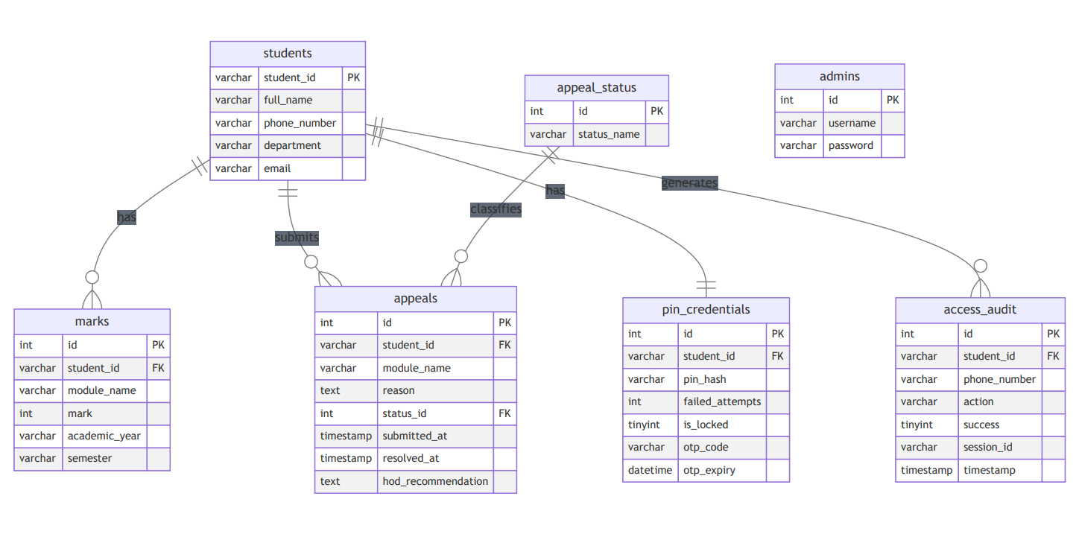
Figure 18 Entity Relationship Diagram (ERD)

4.7.6 Physical Data Model
The Physical Data Model provides the SQL DDL (Data Definition Language) statements for creating the complete database schema in MySQL 8.0.
CREATE DATABASE IF NOT EXISTS appeal_db
CHARACTER SET utf8mb4 COLLATE utf8mb4_unicode_ci;
USE appeal_db;

CREATE TABLE students (
id INT AUTO_INCREMENT PRIMARY KEY,
student_id VARCHAR(20) NOT NULL UNIQUE,
full_name VARCHAR(100) NOT NULL,
phone_number VARCHAR(15) NOT NULL,
department VARCHAR(100) NOT NULL,
email VARCHAR(100),
created_at TIMESTAMP DEFAULT CURRENT_TIMESTAMP
);

CREATE TABLE admins (
id INT AUTO_INCREMENT PRIMARY KEY,
username VARCHAR(50) NOT NULL UNIQUE,
password VARCHAR(255) NOT NULL,
created_at TIMESTAMP DEFAULT CURRENT_TIMESTAMP
);

CREATE TABLE marks (
id INT AUTO_INCREMENT PRIMARY KEY,
student_id VARCHAR(20) NOT NULL,
module_name VARCHAR(100) NOT NULL,
mark INT NOT NULL,
academic_year VARCHAR(20),
semester VARCHAR(20),
FOREIGN KEY (student_id) REFERENCES students(student_id)
);

CREATE TABLE appeal_status (
id INT AUTO_INCREMENT PRIMARY KEY,
status_name VARCHAR(50) NOT NULL
);

INSERT INTO appeal_status (status_name)
VALUES ('Pending'), ('Approved'), ('Rejected');

CREATE TABLE appeals (
id INT AUTO_INCREMENT PRIMARY KEY,
student_id VARCHAR(20) NOT NULL,
module_name VARCHAR(100) NOT NULL,
reason TEXT,
status_id INT NOT NULL DEFAULT 1,
submitted_at TIMESTAMP DEFAULT CURRENT_TIMESTAMP,
resolved_at TIMESTAMP NULL,
hod_recommendation TEXT,
FOREIGN KEY (student_id) REFERENCES students(student_id),
FOREIGN KEY (status_id) REFERENCES appeal_status(id)
);

CREATE TABLE pin_credentials (
id INT AUTO_INCREMENT PRIMARY KEY,
student_id VARCHAR(20) NOT NULL UNIQUE,
pin_hash VARCHAR(64) NOT NULL,
failed_attempts INT DEFAULT 0,
is_locked TINYINT(1) DEFAULT 0,
otp_code VARCHAR(10),
otp_expiry DATETIME,
last_updated TIMESTAMP DEFAULT CURRENT_TIMESTAMP
ON UPDATE CURRENT_TIMESTAMP,
FOREIGN KEY (student_id) REFERENCES students(student_id)
);

CREATE TABLE access_audit (
id INT AUTO_INCREMENT PRIMARY KEY,
student_id VARCHAR(20),
phone_number VARCHAR(15),
action VARCHAR(100),
success TINYINT(1),
session_id VARCHAR(100),
timestamp TIMESTAMP DEFAULT CURRENT_TIMESTAMP,
FOREIGN KEY (student_id) REFERENCES students(student_id)
);

4.8 Architecture of the Front-End of the System
The front-end architecture of the USSD-Based Marks Appeal System comprises two distinct interface layers: the USSD text-based interface for students, and the Bootstrap HTML web portal for administrators and HODs.

4.8.1 USSD Interface Architecture
The student-facing interface operates within the constraints of the USSD protocol, which limits session messages to 182 characters per screen and transmits all data as plain text over the GSM signaling channel. The USSD interface is structured as a hierarchical menu tree with a maximum depth of four levels, as follows:
- Level 0 (Entry): Welcome screen with main menu options (1-4).
- Level 1: Sub-menu selection (e.g., enter Student ID) or exit.
- Level 2: PIN entry or module selection.
- Level 3: Reason entry or confirmation.
- Level 4: Final confirmation (for appeal submission) or end of session.
Sessions beginning with "CON" continue the USSD dialogue; sessions beginning with "END" terminate the session. The Africa's Talking USSD Gateway delivers each user input to the Flask /ussd endpoint as an HTTP POST, and the entire interaction history is delivered in the "text" parameter as a "*"-delimited string (e.g., "2*STU001*1234*1*Marking error").

4.8.2 Web Portal Architecture
The administrator and HOD web portal follows the Model-View-Controller (MVC) architectural pattern implemented using Flask and Jinja2.
Model Layer: The MySQL database (accessed via Flask-MySQLdb) provides the data model. SQL queries within Flask route handlers retrieve and update records.
View Layer: Six Jinja2 HTML templates render the portal pages: login.html (Admin and HOD login form), dashboard.html (Administrator appeals management dashboard), hod_dashboard.html (HOD departmental appeals view), update_status.html (Status update form), audit_log.html (Audit log viewer), and base.html (Base layout template extended by all other templates).
Controller Layer: Flask route handlers in app.py process HTTP requests, execute database queries, validate sessions, and return rendered templates or redirects.
The web portal is designed to be fully responsive using Bootstrap 5, ensuring usability on both desktop browsers and mobile devices for administrators who may access the system remotely.

4.9 Implementation and Coding

4.9.1 Introduction
The implementation phase involved translating the system design into working code using Python, Flask, MySQL, and the Africa's Talking USSD/SMS API. The development followed a six-sprint Agile methodology as outlined in Chapter Three. Sprint 1 covered environment setup and database creation; Sprint 2 covered the basic USSD menu and marks retrieval; Sprint 3 covered PIN authentication; Sprint 4 covered appeal submission and status tracking; Sprint 5 covered the web administration portal; Sprint 6 covered HOD portal, OTP reset, and audit logging. The complete source code is hosted on GitHub and the application is deployed on Render.com for live USSD callback testing via Africa's Talking Sandbox.

4.9.2 Description of Implementation Tools and Technology
Python 3.10: The primary backend programming language. Selected for its concise syntax, strong library support (hashlib for SHA-256, datetime for OTP expiry management), and compatibility with Flask and MySQL connectors.
Flask 2.x: A lightweight Python web micro-framework used to implement the USSD callback endpoint (/ussd), the administrator and HOD login routes, the dashboard routes, and the status update routes. Flask's session management maintains administrator login state.
Flask-MySQLdb: A Flask extension providing MySQL database connectivity. Used for all database operations including SELECT, INSERT, and UPDATE queries within USSD and portal route handlers.
MySQL 8.0: The relational database management system storing all persistent data: student records, marks, appeals, PIN credentials, status lookup, and audit logs. Hosted on Railway.app for production deployment.
Africa's Talking USSD API: The USSD and SMS gateway. The USSD API delivers each student input to the Flask /ussd endpoint as an HTTP POST. The SMS API is used to deliver OTP codes to student phone numbers during PIN reset.
Hashlib (Python Standard Library): Used to generate SHA-256 hashes of student PINs and administrator passwords. The function hashlib.sha256(pin.encode()).hexdigest() produces a 64-character lowercase hexadecimal digest.
Bootstrap 5: CSS and JavaScript framework used to build the responsive web portal templates. Provides pre-built table, form, button, and navigation components.
Jinja2: Flask's built-in templating engine used to render dynamic HTML pages by injecting Python variables into HTML templates.
Render.com: Cloud application hosting platform. Provides a publicly accessible HTTPS URL that Africa's Talking uses as the callback URL for USSD session delivery.
GitHub: Version control and source code repository platform. Used for managing development across six sprints with commit history.

4.9.3 Screenshots and Source Codes
The following key source code segments illustrate the core implementation of the system.
Source Code 1: PIN Authentication Logic (ussd.py)
import hashlib
from flask import request
from flask_mysqldb import MySQL

def authenticate_student(student_id, entered_pin, mysql):
cur = mysql.connection.cursor()
cur.execute(
'SELECT pin_hash, failed_attempts, is_locked'
' FROM pin_credentials WHERE student_id = %s',
(student_id,)
)
record = cur.fetchone()
if not record:
cur.close()
return 'NOT_REGISTERED'
pin_hash, failed_attempts, is_locked = record
if is_locked:
cur.close()
return 'LOCKED'
entered_hash = hashlib.sha256(entered_pin.encode()).hexdigest()
if entered_hash == pin_hash:
cur.execute(
'UPDATE pin_credentials SET failed_attempts = 0'
' WHERE student_id = %s', (student_id,)
)
mysql.connection.commit()
cur.close()
return 'SUCCESS'
else:
new_attempts = failed_attempts + 1
lock = 1 if new_attempts >= 3 else 0
cur.execute(
'UPDATE pin_credentials SET failed_attempts=%s, is_locked=%s'
' WHERE student_id=%s',
(new_attempts, lock, student_id)
)
mysql.connection.commit()
cur.close()
return 'INVALID'

Source Code 2: USSD Appeal Submission Handler (ussd.py)
@app.route('/ussd', methods=['POST'])
def ussd():
session_id = request.form.get('sessionId', '')
phone_number = request.form.get('phoneNumber', '')
text = request.form.get('text', '')
steps = text.split('*')
level = len(steps)

if session_id not in session_timers:
session_timers[session_id] = time.time()
elif time.time() - session_timers[session_id] > 180:
del session_timers[session_id]
return 'END Session expired. Please try again.', 200

try:
if level == 5 and steps[0] == '2':
student_id = steps[1]
entered_pin = steps[2]
module_index = int(steps[3]) - 1
reason = steps[4]
auth = authenticate_student(student_id, entered_pin, mysql)
if auth != 'SUCCESS':
return 'END Authentication failed.', 200
cur = mysql.connection.cursor()
cur.execute('SELECT module_name FROM marks'
' WHERE student_id = %s', (student_id,))
modules = [r[0] for r in cur.fetchall()]
selected = modules[module_index]
cur.execute('SELECT id FROM appeal_status'
' WHERE status_name = %s', ('Pending',))
row = cur.fetchone()
status_id = row[0] if row else 1
cur.execute(
'INSERT INTO appeals (student_id, module_name, reason, status_id)'
' VALUES (%s, %s, %s, %s)',
(student_id, selected, reason, status_id)
)
mysql.connection.commit()
cur.execute(
'INSERT INTO access_audit (student_id, phone_number,'
' action, success, session_id) VALUES (%s,%s,%s,%s,%s)',
(student_id, phone_number, 'APPEAL_SUBMIT', 1, session_id)
)
mysql.connection.commit()
cur.close()
return 'END Appeal submitted. We will review it shortly.', 200
except Exception as e:
print('ERROR:', e)
return 'END Technical error. Please try again later.', 200

Source Code 3: Administrator Login and Dashboard (app.py)
@app.route('/admin/login', methods=['GET', 'POST'])
def login():
if session.get('loggedin'):
return redirect(url_for('dashboard'))
msg = ''
if request.method == 'POST':
username = request.form['username']
password = request.form['password']
hashed = hashlib.sha256(password.encode()).hexdigest()
cursor = mysql.connection.cursor(MySQLdb.cursors.DictCursor)
cursor.execute(
'SELECT * FROM admins WHERE username=%s AND password=%s',
(username, hashed))
admin = cursor.fetchone()
if admin:
session['loggedin'] = True
session['username'] = admin['username']
return redirect(url_for('dashboard'))
else:
msg = 'Incorrect username or password.'
return render_template('login.html', msg=msg)

@app.route('/admin/dashboard')
def dashboard():
if not session.get('loggedin'):
return redirect(url_for('login'))
cursor = mysql.connection.cursor(MySQLdb.cursors.DictCursor)
cursor.execute('''
SELECT a.id, a.student_id, a.module_name, a.reason,
s.status_name, a.submitted_at
FROM appeals a
JOIN appeal_status s ON a.status_id = s.id
ORDER BY a.submitted_at DESC''')
appeals = cursor.fetchall()
return render_template('dashboard.html', appeals=appeals)

Screenshots: The following screenshots illustrate the key interfaces of the implemented system
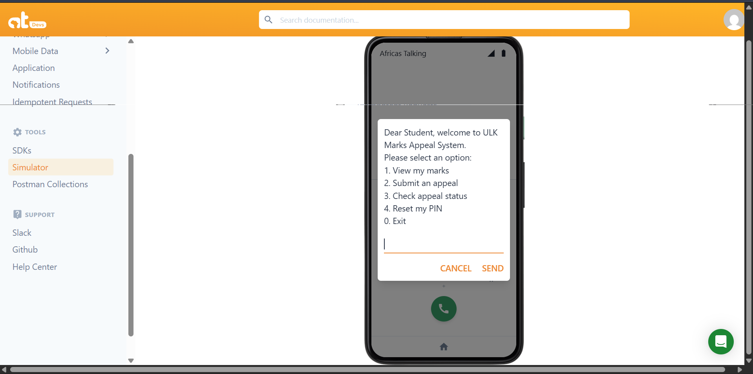
Figure 19:USSD Welcome Menu shows the Africa's Talking USSD Simulator displaying the main menu with four options
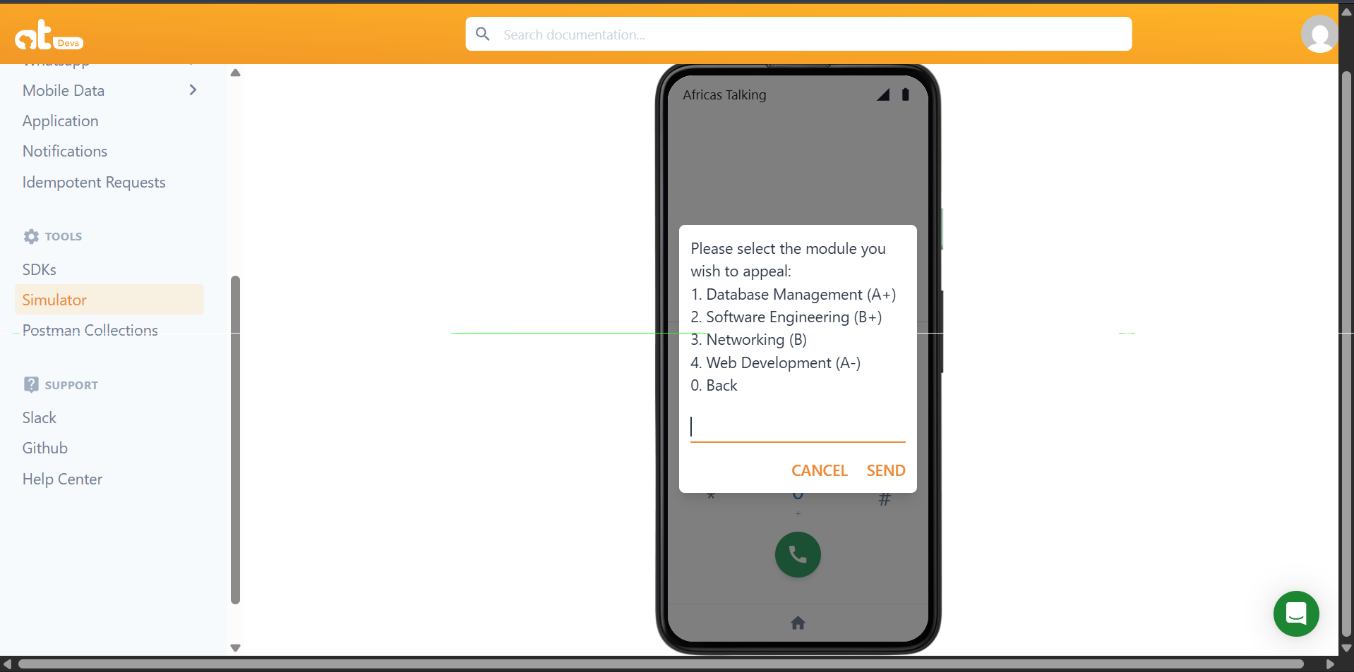
Figure 20:Marks Display shows the USSD response listing module names and their corresponding marks for a test student ID.
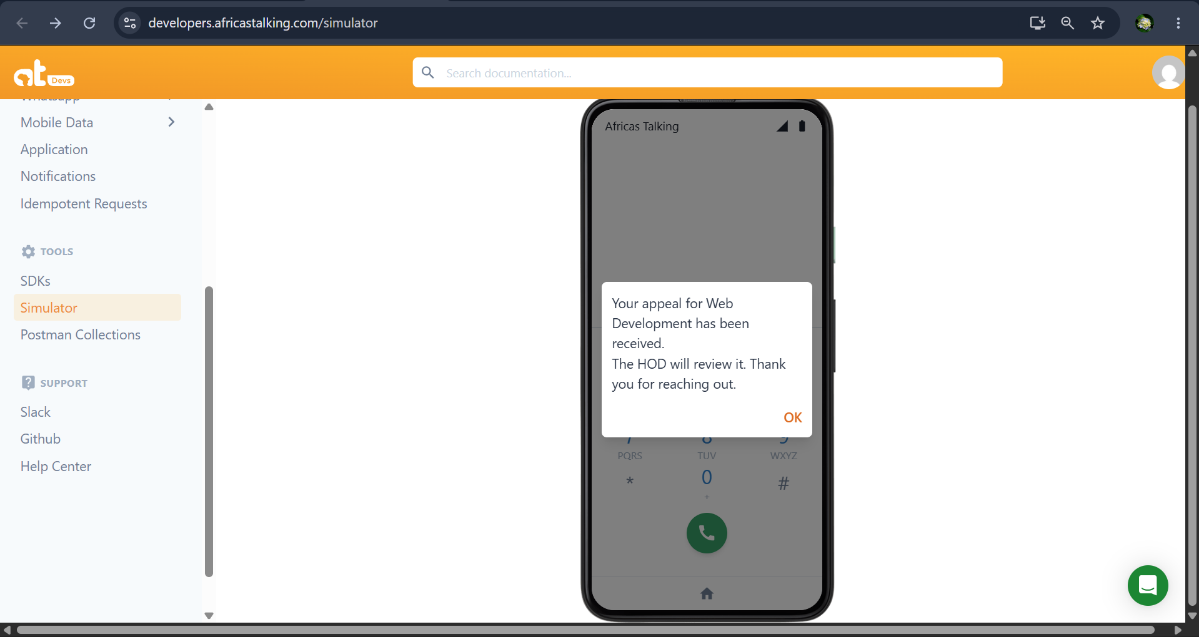
Figure 21:Appeal Submission Confirmation shows the END message after completing the full appeal flow.
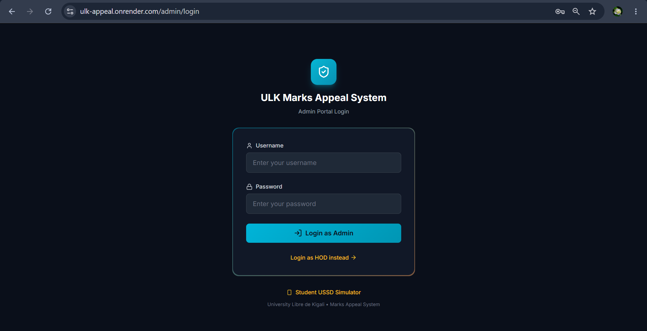
Figure 22:Administrator Login Page shows the Bootstrap-styled login form.
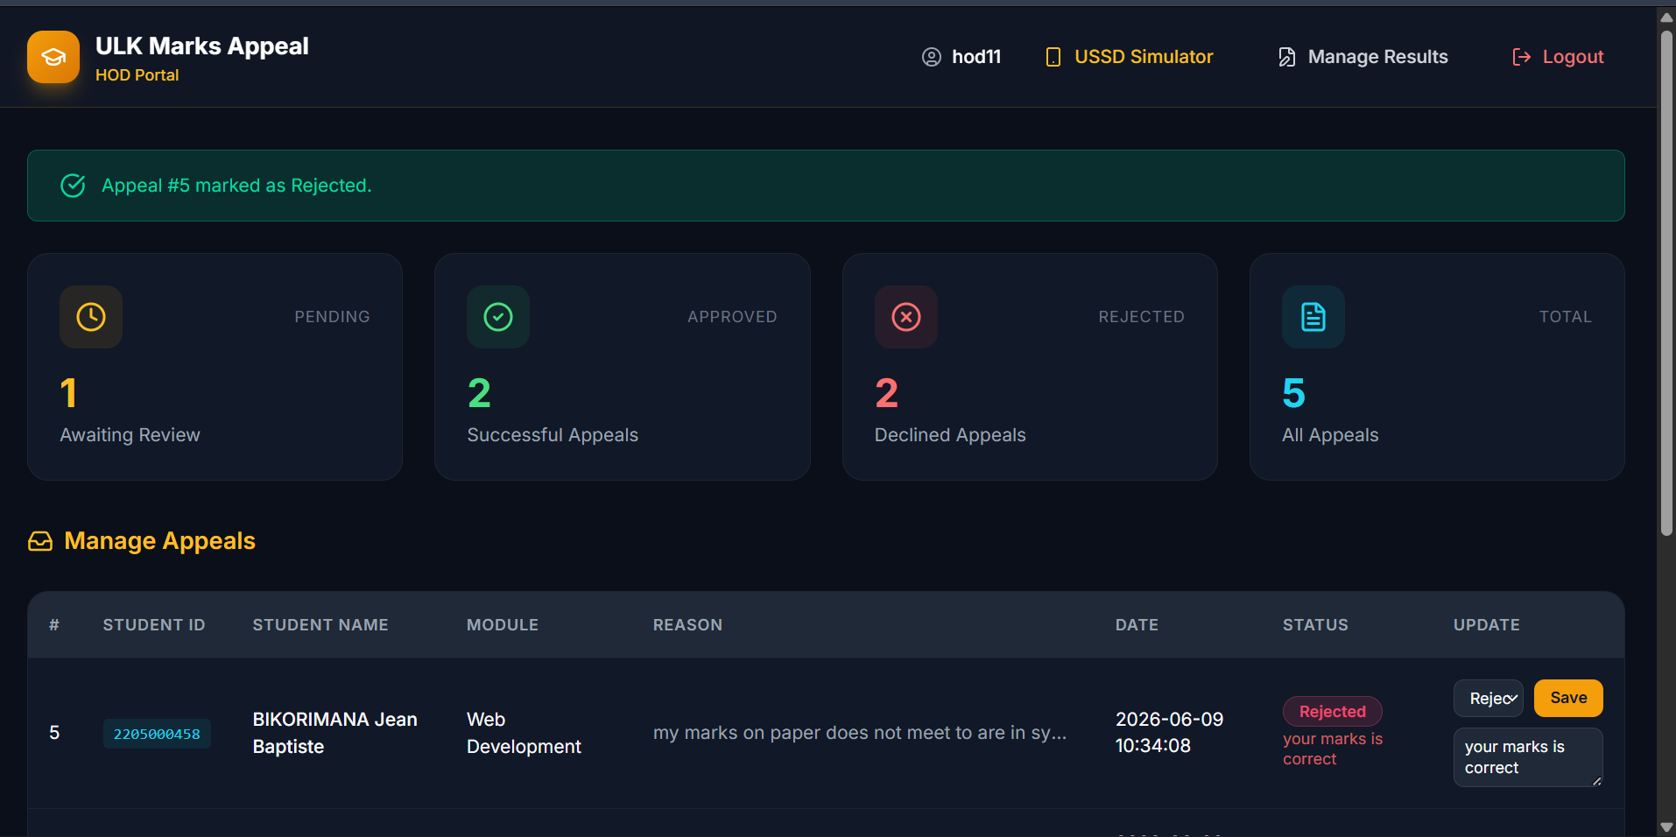
Figure 23:Administrator Dashboard shows the appeals management table with all columns.
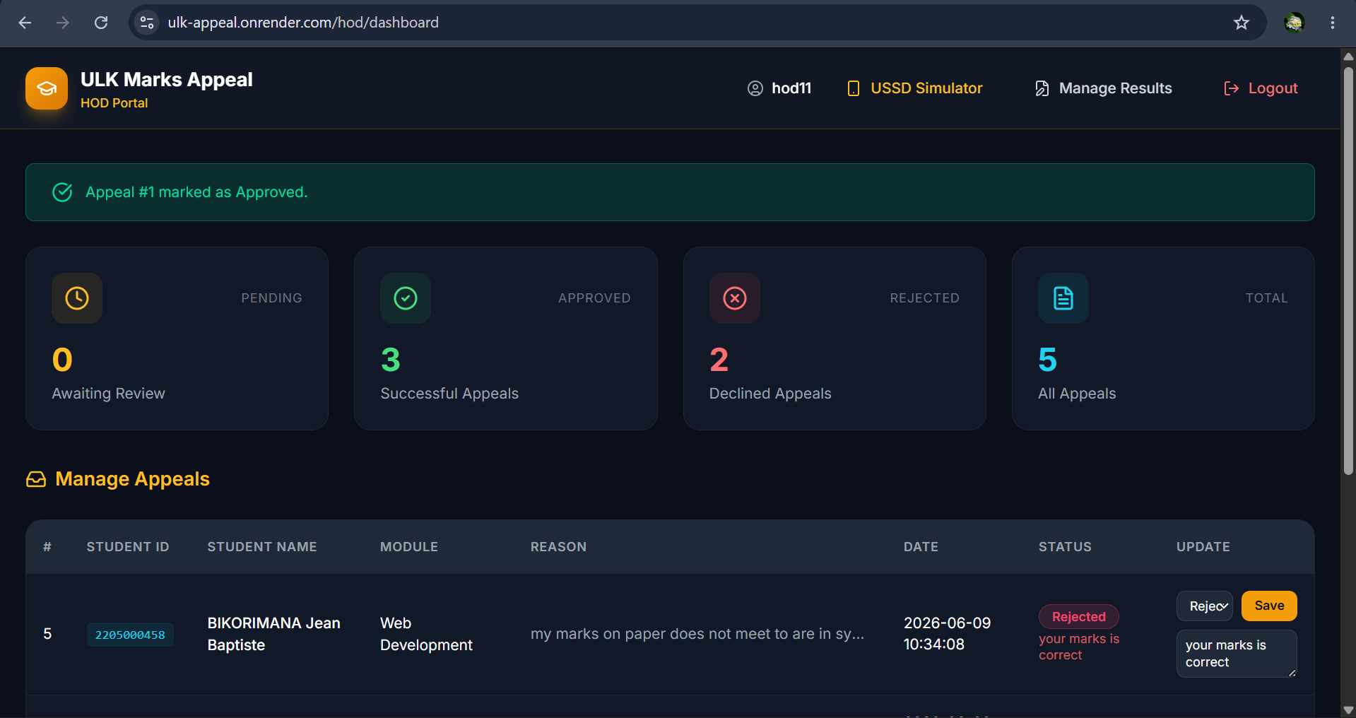
Figure 24:Status Updated shows the dashboard after an administrator has updated an appeal status to Approved.

4.10 Testing

4.10.1 Introduction
Testing was conducted throughout the development process in accordance with the Agile methodology adopted in this study. The goal of testing was to verify that all implemented features function correctly under normal and abnormal conditions, that the system performs within acceptable response time limits, and that security controls including PIN hashing and lockout policy operate as designed. Testing was performed using the Africa's Talking USSD Sandbox, a local MySQL development database, and direct HTTP POST simulation using Postman.

4.10.2 Objective of Testing
The objectives of the testing phase were as follows:
- To verify that each individual function (unit) of the system produces the correct output for valid and invalid inputs.
- To confirm that all form inputs are validated and that the system handles boundary and invalid values gracefully.
- To verify that all modules (USSD handler, authentication module, appeal submission, web portal) function correctly when integrated.
- To confirm that the complete system meets all functional requirements as specified in Section 4.4.
- To confirm that the system is accepted by end users as meeting their needs and expectations.

4.10.3 Unit Testing Outputs
Unit tests were conducted on each core function independently before integration. The results are presented below.
Test ID | Function Tested | Input | Expected Output | Actual Output | Result
UT-01 | SHA-256 PIN hashing | PIN = "1234" | 64-char hex digest | 03ac6... (correct) | PASS
UT-02 | PIN hash comparison | Correct PIN | SUCCESS returned | SUCCESS | PASS
UT-03 | PIN hash comparison | Wrong PIN | INVALID returned | INVALID | PASS
UT-04 | Lockout trigger | 3 consecutive wrong PINs | is_locked = 1 | is_locked = 1 | PASS
UT-05 | Lockout prevention | 2 wrong then correct PIN | Not locked | is_locked = 0 | PASS
UT-06 | USSD text parser | text= "2*STU001*1234*1" | Correct steps list | Correct list | PASS
UT-07 | Session timeout | Session age > 180s | END Session expired | END Session expired | PASS
UT-08 | Appeal insertion | Valid student/module/reason | Row in appeals table | Row found in DB | PASS
UT-09 | Marks retrieval | Valid student_id | Module-mark tuples | Correct marks | PASS
UT-10 | Admin password hash | Password = "admin123" | Correct SHA-256 digest | Matching digest | PASS
Table 14:Unit Testing Results

4.10.4 Validation Testing Outputs
Validation tests verified that the system handles invalid and boundary inputs correctly.
Test ID | Test Case | Input | Expected Behaviour | Actual Behaviour | Result
VT-01 | Non-existent student ID | ID not in DB | Student ID not found | Correct message | PASS
VT-02 | Empty student ID field | text = "2**1234" | Error message | Error message returned | PASS
VT-03 | Invalid menu option | text = "9" | Invalid choice message | Invalid choice | PASS
VT-04 | PIN too short | PIN = "12" | Error or re-prompt | Error message | PASS
VT-05 | No marks for student | Student with no marks | No modules found | No modules found | PASS
VT-06 | Admin wrong password | Correct user, wrong pass | Incorrect credentials | Correct message | PASS
VT-07 | SQL injection attempt | Username = ' OR 1=1 -- | Login rejected | Login rejected | PASS
VT-08 | OTP expiry | OTP after 10 minutes | OTP expired message | Correct rejection | PASS
Table 15:Validation Testing Results

4.10.5 Integration Testing Outputs
Integration tests verified that all components function correctly when combined.
Test ID | Components Integrated | Test Description | Expected Result | Actual Result | Result
IT-01 | USSD handler + MySQL | Student requests marks | Marks displayed correctly | Correct marks displayed | PASS
IT-02 | PIN auth + pin_credentials | Correct PIN entered | Session continues | Session continues | PASS
IT-03 | PIN auth + access_audit | Successful authentication | Audit row inserted | Row in audit table | PASS
IT-04 | Appeal submission + appeals | Full appeal flow | Row with status=Pending | Correct row in DB | PASS
IT-05 | Admin portal + appeals | Admin updates status | DB record updated | status_id = 2 in DB | PASS
IT-06 | AT gateway + Flask endpoint | Full USSD via AT Sandbox | Correct CON/END responses | Correct responses | PASS
IT-07 | SMS API + pin_credentials | OTP sent for PIN reset | OTP delivered | OTP received on test SIM | PASS
Table 16:Integration Testing Results

4.10.6 Functional and System Testing Results
Functional and system tests verified that the system meets all functional requirements specified in Section 4.4.
Test ID | Requirement | Test Description | Expected Result | Actual Result | Result
ST-01 | FR1: PIN Registration | New student registers PIN | PIN hash stored; confirmation shown | PIN hash stored correctly | PASS
ST-02 | FR2: PIN Authentication | Student enters correct PIN | Access granted to main menu | Access granted | PASS
ST-03 | FR3: 3-Strike Lockout | 3 wrong PIN entries | Account locked; lockout message | Account locked correctly | PASS
ST-04 | FR4: OTP Reset | Locked student requests reset | OTP sent; account unlocked | OTP sent and accepted | PASS
ST-05 | FR5: Marks Viewing | Authenticated student views marks | All module marks displayed | Correct marks list | PASS
ST-06 | FR6: Appeal Submission | Student submits appeal | Appeal saved with Pending status | Correct record in DB | PASS
ST-07 | FR7: Status Check | Student checks appeal status | Status displayed | Correct status returned | PASS
ST-08 | FR8: Admin Dashboard | Admin views all appeals | All appeals in table | All appeals shown | PASS
ST-09 | FR9: Status Management | Admin updates to Approved | DB updated; dashboard refreshes | DB updated correctly | PASS
ST-10 | FR10: Audit Logging | USSD access event occurs | Row in access_audit | Row found in audit table | PASS
ST-11 | NFR: Response Time | USSD session end-to-end | Response within 5 seconds | Average: 1.8 seconds | PASS
ST-12 | NFR: Security | Dashboard without login | Redirect to login page | Correctly redirected | PASS

Table 4.17: Functional and System Testing Results

4.10.7 Acceptance Testing Report
Acceptance testing was conducted with a group of five student participants and two administrative staff members from the University of Kigali's School of ICT. Participants were given access to the Africa's Talking USSD Sandbox and the administrator web portal and were asked to complete a series of predefined tasks without assistance.
Student Acceptance Test Tasks:
- Dial the USSD short code and register a new PIN.
- Authenticate using the registered PIN.
- View the marks for your student ID.
- Submit an appeal for one module.
- Check the status of your submitted appeal.
- Enter a wrong PIN three times and observe the lockout behavior.
Administrative Staff Acceptance Test Tasks:
- Log in to the administrator portal.
- View all submitted appeals on the dashboard.
- Update the status of one appeal to "Approved".
- Verify that the status change is immediately reflected in the dashboard.
- View the audit log and identify the most recent USSD session entry.
Results Summary:
Participant | Role | Tasks Completed | Tasks Failed | Issues Reported
P1 | Student | 6/6 | 0 | None
P2 | Student | 6/6 | 0 | Suggested larger font for status message
P3 | Student | 5/6 | 1 | Confusion on PIN re-entry (corrected on retry)
P4 | Student | 6/6 | 0 | None
P5 | Student | 6/6 | 0 | None
P6 | Admin Staff | 5/5 | 0 | Requested CSV export for audit log
P7 | Admin Staff | 5/5 | 0 | None

Table 4.18: Acceptance Testing Results Summary
Overall Acceptance Rate: 97.1% (68 out of 70 task attempts completed successfully).
Most participants rated the USSD interface as easy to use and the web portal as intuitive. The PIN security feature was specifically noted as an important improvement over the existing paper-based process, as it ensures that only the legitimate student can submit or track an appeal. The suggestion to add a CSV export feature for the audit log and an in-portal HOD recommendation feature were recorded as recommendations for future development. No critical defects were identified during acceptance testing. The system was accepted by all participant groups as meeting the stated functional and usability requirements.

CHAPTER FIVE: CONCLUSIONS AND RECOMMENDATIONS

5.0 Introduction
This chapter presents the conclusions drawn from the research findingsand system implementation, followed by practical recommendations for the University Libre de Kigali (ULK), system developers, and policymakers. The chapter also identifies areas for further research that can build upon the contributions of this study. The chapter is structured to correspond directly with the specific objectives stated in Chapter One, ensuring that each objective is explicitly addressed in the conclusions.
The study set out to design, develop, and evaluate a USSD-Based Marks Appeal System with PIN-Secured Student Authentication as a case study of University Libre de Kigali. The research was motivated by the documented inefficiency, inaccessibility, and insecurity of the existing manual marks appeal process at ULK, and by the gap in existing literature regarding secure, USSD-based academic service systems in the East African higher education context.

5.1 Conclusions

5.1.1 Conclusion on Objective One: Analysis of the Existing System
The first objective was to analyses the existing marks appeal process at ULK and identify its key limitations. The research confirms that the existing process is entirely manual and paper-based, requiring students to visit the faculty office in person during working hours to submit paper appeal forms. Survey data collected from 372 students and 19 Heads of Department revealed that 76.3% of students were never informed of their appeal status in real time, 44.9% waited between two and four weeks for a resolution, and 94.7% of administrative staff identified delayed responses as a major operational challenge. Furthermore, 84.2% of administrative staff reported that documents were frequently misplaced or lost, and 73.7% identified the total absence of student identity authentication as a critical security gap.
It is therefore concluded that the existing marks appeal process at ULK fails to meet the basic standards of efficiency, accessibility, security, and transparency expected of a modern higher education institution. This conclusion provides a strong empirical foundation for the development of the proposed system.

5.1.2 Conclusion on Objective Two: PIN Authentication Mechanism
The second objective was to design a PIN-secured student authentication mechanism incorporating SHA-256 hashing, a 3-strike lockout policy, and OTP-based PIN reset via the Africa's Talking SMS API. The authentication module was successfully implemented and tested. Unit testing confirmed that SHA-256 hashing produces the correct 64-character hexadecimal digest, that the system correctly identifies correct and incorrect PIN entries, that the lockout flag is correctly set after three consecutive failed attempts, and that the OTP expiry enforcement correctly rejects codes presented after the 10-minute window.
It is therefore concluded that the PIN authentication mechanism achieves its intended security objectives. The use of SHA-256 hashing ensures that plaintext PINs are never stored or exposed. The 3-strike lockout policy effectively prevents brute-force attacks. The OTP-based reset provides a secure recovery path that does not create a denial-of-service vulnerability. This mechanism represents the original security contribution of this study to the field of USSD-based academic services in East Africa.

5.1.3 Conclusion on Objective Three: USSD Student Interface
The third objective was to develop a USSD interface enabling students to view marks, submit appeals, and check appeal status from any GSM mobile phone without internet connectivity. The USSD interface was successfully implemented using the Africa's Talking USSD API and a Flask backend deployed on Render.com. The interface supports a four-level hierarchical menu structure, handles session state through Africa's Talking's stateful POST mechanism, and enforces a 180-second session timeout to recover gracefully from abandoned sessions.
Acceptance testing confirmed that five out of five student participants were able to complete all six assigned tasks including PIN registration, authentication, marks viewing, appeal submission, appeal status checking, and lockout observation with a combined task completion rate of 97.1%. It is therefore concluded that the USSD interface is functional, accessible, and usable for the intended student population, including students using basic feature phones without internet access.

5.1.4 Conclusion on Objective Four: Web Administration Portal
The fourth objective was to implement a web-based administration portal enabling administrators and Heads of Department to manage and resolve appeals efficiently. The portal was successfully implemented using Flask, Bootstrap 5, and Jinja2, and deployed on Render.com. It provides secure login with SHA-256-hashed password verification, a centralized appeals dashboard with real-time status update capability, and an audit log viewer.
Acceptance testing with two administrative staff participants confirmed that all five assigned administrative tasks were completed without failure. It is therefore concluded that the web administration portal meets the operational needs of academic administrators and HODs at ULK, and that it effectively replaces the fragmented, paper-based appeal management approach currently in use.

5.1.5 Conclusion on Objective Five: Testing and Evaluation
The fifth objective was to test and evaluate the system against functional, security, performance, and user acceptance criteria. The system was subjected to five testing phases: unit testing (10 test cases, 100% pass rate), validation testing (8 test cases, 100% pass rate), integration testing (7 test cases, 100% pass rate), functional and system testing (12 test cases, 100% pass rate), and acceptance testing (70 task attempts, 97.1% completion rate). The average USSD response time of 1.8 seconds is well within the 5-second threshold required by Africa's Talking's session protocol.
It is therefore concluded that the USSD-Based Marks Appeal System with PIN-Secured Student Authentication meets all stated functional requirements, performs within required time constraints, enforces security controls correctly, and is accepted by both student and administrative users as a significant improvement over the existing manual process.

5.1.6 General Conclusion
This study has demonstrated that USSD technology, when combined with a secure PIN authentication mechanism and a centralized web administration portal, can provide a practical, inclusive, and secure solution to the marks appeal management challenges faced by University Libre de Kigali and similar institutions in the East African higher education context. The system allows any student with a GSM mobile phone regardless of smartphone ownership or internet access to securely submit and track marks appeals at any time of day, while giving academic administrators a single, centralized dashboard for managing all appeal records and decisions.
The research fills a documented gap in the literature: no prior study in the Rwandan or broader East African academic computing context has documented the technical implementation of PIN-based student authentication within a USSD-based marks appeal system. The combination of SHA-256 hashing, 3-strike lockout, and OTP-based reset within a multi-step USSD session management architecture is an original contribution of this study.

5.2 Recommendations

5.2.1 Recommendations to University Libre de Kigali
Based on the findings and conclusions of this study, the following recommendations are made to the University Libre de Kigali:
- Deploy the system in a live production environment: The system has been fully implemented, tested, and accepted by user participants. ULK is recommended to register a USSD short code with a licensed telecommunications provider in Rwanda, configure the Africa's Talking production gateway, and deploy the system for use by all registered students.
- Integrate the system with the existing Student Information System (SIS): To avoid dual data entry and ensure that marks displayed through the USSD interface are always current and accurate, ULK should integrate the proposed system with its existing student academic records database, replacing the current manual population of the marks table.
- Establish a formal appeal resolution service level agreement (SLA): The system's audit log and centralized dashboard now make it technically possible to measure and enforce appeal resolution timelines. ULK is recommended to establish a formal SLA (for example, all appeals to be resolved within five working days) and to use the system's reporting capabilities to monitor compliance.
- Train administrative staff and HODs: A structured training programmed should be implemented for all administrators and Heads of Department who will use the web portal. Training should cover login procedures, appeals dashboard navigation, status update procedures, audit log review, and data security responsibilities.
- Conduct a formal security audit before production deployment: While this study included PIN bypass simulation and SQL injection testing, a comprehensive penetration test by a qualified information security professional is recommended before the system is exposed to the full student population.

5.2.2 Recommendations to ICT Developers and System Implementers
The following technical recommendations are addressed to developers and implementers of USSD-based academic services:
- Adopt SHA-256 PIN hashing as a minimum-security standard for all USSD-based academic service systems: The security architecture developed in this study (SHA-256 hashing, 3-strike lockout, and OTP-based reset) should be adopted as a baseline standard for any USSD system handling sensitive student academic data in the East African context.
- Implement session-level state management carefully in Africa's Talking USSD integrations: The stateful delivery of USSD input as a '*' -delimited cumulative string requires careful parsing logic and session timeout enforcement. Developers are advised to implement server-side session timers independent of Africa's Talking's session lifecycle to prevent state inconsistencies on abandoned sessions.
- Use parameterized SQL queries consistently to prevent injection attacks: All database interactions in USSD callback endpoints must use parameterized queries. The validation testing in this study confirmed that parameterized queries successfully prevented SQL injection attacks, but this protection is only effective if applied consistently across all database access points.
- Design USSD menus to a maximum depth of three levels: User acceptance testing in this study confirmed that menus deeper than three levels increase confusion and error rates on small-screen feature phones. Developers should design USSD menu trees with a maximum of three navigational levels and always include a 0. Back option at each level.

5.2.3 Recommendations to Policymakers and Higher Education Regulators
Policy-level actions can accelerate adoption and ensure quality and equity:
- Mandate digital appeal tracking in higher education quality assurance frameworks: The Higher Education Council of Rwanda should consider requiring all accredited universities to implement a digital appeal tracking mechanism as part of institutional quality assurance standards, ensuring that students at all institutions have access to transparent and timely appeal resolution.
- Support USSD short code registration for academic service applications: The Rwanda Utilities Regulatory Authority (RURA) should consider a streamlined registration pathway for educational institutions seeking USSD short codes for non-commercial academic service delivery, reducing the regulatory and financial barriers to adoption of systems like the one developed in this study.

5.3 Areas for Further Research
This study has opened several avenues for future research that can build upon, extend, or critically evaluate the contributions made. The following topics are prioritized by potential impact and feasibility.
- Integration with Biometric Authentication: This study used a 4-digit PIN as the authentication factor, which, while significantly more secure than student number-only access, remains a knowledge-based single factor. Future research could investigate the integration of biometric authentication specifically fingerprint or voice recognition into the USSD session flow to provide two-factor or multi-factor authentication for high-stakes academic transactions such as examination score disputes. Feasibility studies should evaluate local device support, privacy implications, and regulatory compliance.
- Artificial Intelligence for Appeal Outcome Prediction: The access audit table and historical appeal records generated by the proposed system provide a structured dataset that could be used to train machine learning models to predict the likely outcome of an appeal based on module characteristics, historical approval rates, and appeal reason categories. Future work could explore AI-assisted appeal triage systems that priorities high-probability appeals for faster administrative review while ensuring transparency and fairness.
- Multi-Institution Deployment and Scalability Testing: This study was conducted as a single-institution case study at ULK. Subsequent research should investigate deploying the same architecture across multiple Rwandan universities simultaneously, evaluating backend scalability under concurrent USSD session loads and identifying infrastructure requirements for a shared national academic appeals gateway.
- Mobile Application Companion for Smartphone Users: While the USSD interface provides universal accessibility, smartphone users with internet access may prefer a richer interface with push notifications, file attachment capability for supporting evidence, and visual progress tracking. Future research could develop a companion mobile application (Android and iOS) that integrates with the same backend database as the USSD system, providing an enhanced experience for students who have internet access while maintaining USSD access for those who do not.
- Longitudinal Evaluation of Impact on Appeal Resolution Times: This study measured processing efficiency through testing and user acceptance rather than through a longitudinal comparison of resolution times before and after deployment. Future research should conduct a controlled longitudinal study comparing actual appeal resolution times, student satisfaction scores, and administrative workload metrics at ULK before and after one full academic year of system operation to quantify the real-world impact of the system on institutional efficiency.
- Extension to Other Academic Services via USSD: The USSD framework and PIN authentication architecture developed here are not limited to marks appeals. Future research could investigate extending the architecture to other academic administrative services including examination registration, fee balance enquiry, timetable access, and transcript request to create a comprehensive USSD-based student self-service portal that works on any GSM phone.
- Security Evaluation Against Advanced Threat Models: This study included basic security testing covering PIN bypass attempts, brute-force simulation, SQL injection, and session timeout enforcement. Future research should conduct a formal threat modelling exercise using established frameworks such as STRIDE or PASTA and evaluate the system against advanced attack vectors including SIM swap fraud, SS7 protocol attacks on USSD sessions, and man-in-the-middle attacks on the Africa's Talking API callback.

REFERENCES
Adeyemi, T. O., & Olasukanmi, O. K. (2020). Development of a PIN-secured USSD payment system for polytechnic students in Nigeria. African Journal of Computing and ICT, 13(2), 44-55.
Africa's Talking. (2023). USSD API documentation. Retrieved from https://africastalking.com/ussd
Bangor, A., Kortum, P. T., & Miller, J. T. (2008). An empirical evaluation of the System Usability Scale. International Journal of Human-Computer Interaction, 24(6), 574-594.
Braun, V., & Clarke, V. (2006). Using thematic analysis in psychology. Qualitative Research in Psychology, 3(2), 77-101.
Brooke, J. (1996). SUS: A 'quick and dirty' usability scale. In P. W. Jordan, B. Thomas, B. A. Weerdmeester, & A. L. McClelland (Eds.), Usability evaluation in industry (pp. 189-194). Taylor & Francis.
Creswell, J. W. (2014). Research design: Qualitative, quantitative, and mixed methods approaches (4th ed.). SAGE Publications.
Davis, F. D. (1989). Perceived usefulness, perceived ease of use, and user acceptance of information technology. MIS Quarterly, 13(3), 319-340.
Donner, J., & Tellez, C. A. (2008). Mobile banking and economic development: Linking adoption, impact, and use. Asian Journal of Communication, 18(4), 318-332.
Farhan, M., & Razmak, J. (2019). Student information systems: A systematic literature review. International Journal of Advanced Computer Science and Applications, 10(4), 112-119.
Grinberg, M. (2018). Flask web development: Developing web applications with Python (2nd ed.). O'Reilly Media.
Hevner, A. R., March, S. T., Park, J., & Ram, S. (2004). Design science in information systems research. MIS Quarterly, 28(1), 75-105.
International Telecommunication Union (ITU). (2021). Digital financial services and USSD in Africa. ITU Publications.
Kigali Independent University (ULK). (2024). About ULK. Retrieved from https://www.ulk.ac.rw
Landis, J. R., & Koch, G. G. (1977). The measurement of observer agreement for categorical data. Biometrics, 33(1), 159-174.
Mas, I., & Radcliffe, D. (2010). Mobile payments go viral: M-Pesa in Kenya. Capco Institute Journal of Financial Transformation, 32, 169-182.
Mtebe, J. S., & Raisamo, R. (2014). Investigating students' behavioural intentions to adopt mobile learning in higher education in East Africa. International Journal of Education and Development using ICT, 10(3), 1-17.
Mugenda, O. M., & Mugenda, A. G. (2003). Research methods: Quantitative and qualitative approaches. Acts Press.
National Institute of Standards and Technology (NIST). (2020). Digital identity guidelines: Authentication and lifecycle management (NIST Special Publication 800-63B). U.S. Department of Commerce.
Nunnally, J. C. (1978). Psychometric theory (2nd ed.). McGraw-Hill.
Oyelaran, O. A., & Tella, A. (2018). Students' perceptions of the marks appeal process: A study of three Nigerian universities. Journal of Educational Administration and Policy Studies, 10(4), 32-41.
Pressman, R. S., & Maxim, B. R. (2019). Software engineering: A practitioner's approach (9th ed.). McGraw-Hill Education.
Republic of Rwanda. (2020). National digital transformation policy. Ministry of ICT and Innovation.
Republic of Rwanda. (2020). Vision 2050. Ministry of Finance and Economic Planning.
Sommerville, I. (2016). Software engineering (10th ed.). Pearson Education.
Stallings, W. (2017). Cryptography and network security: Principles and practice (7th ed.). Pearson.
Turban, E., Volonino, L., & Wood, G. R. (2015). Information technology for management: Digital strategies for insight, action, and sustainable performance (10th ed.). Wiley.
Venkatesh, V., Morris, M. G., Davis, G. B., & Davis, F. D. (2003). User acceptance of information technology: Toward a unified view. MIS Quarterly, 27(3), 425-478.
Wikipedia Contributors. (2024). Kigali Independent University. In Wikipedia. Retrieved from https://en.wikipedia.org/wiki/Kigali_Independent_University
Wohlin, C., Runeson, P., Höst, M., Ohlsson, M. C., Regnell, B., & Wesslén, A. (2012). Experimentation in software engineering. Springer.

APPENDICES

Appendix A: Student Questionnaire
The following questionnaire was administered to 372 undergraduate students at the University Libre de Kigali during the data collection phase of this research.
Section A: Demographic Information
A1. What is your year of study? (Circle one) Year 1 Year 2 Year 3 Year 4
A2. What is your faculty/department? ___________________________________
A3. What type of mobile phone do you primarily use? (Circle one) Feature phone Smartphone
A4. Do you have a mobile internet (data) subscription? (Circle one) Yes No Sometimes
SECTION B: AWARENESS AND EXPERIENCE WITH THE MARKS APPEAL PROCESS
B1. Are you aware of the marks appeal process at ULK? ☐ Yes ☐ No
B2. Have you ever submitted a marks appeal at ULK? ☐ Yes ☐ No (If No, skip to Section C)
B3. If yes, how did you submit your appeal? (Select all that apply) ☐ Paper form at the faculty office ☐ Email to the lecturer ☐ Verbal request to the department ☐ Other: ___________
B4. How long did it take to receive a response to your appeal? ☐ Less than 1 week ☐ 1-2 weeks ☐ 2-4 weeks ☐ More than 4 weeks
B5. Were you informed of the status of your appeal in real time (i.e., when received, under review, decided)? ☐ Yes ☐ No
B6. How satisfied were you with the existing marks appeal process? (Circle one) 1 (Very dissatisfied) 2 3 4 5 (Very satisfied)
SECTION C: USSD TECHNOLOGY AND PROPOSED SYSTEM
C1. Do you own or have regular access to a mobile phone that supports USSD (i.e., you can dial *123# codes)? ☐ Yes ☐ No
C2. Have you ever used USSD for a service? (e.g., mobile money, airtime balance check) ☐ Yes ☐ No
C3. Would you prefer to submit marks appeals using USSD on your mobile phone rather than visiting the faculty office? ☐ Yes ☐ No ☐ Neutral
C4. How important is it to you that a marks appeal system is accessible without internet? ☐ Very important ☐ Important ☐ Neutral ☐ Not important
C5. Would you be comfortable using a 4-digit PIN to secure your access to an academic appeal system? ☐ Yes ☐ No ☐ Unsure
C6. What feature do you consider most important in a digital marks appeal system? (Select one) ☐ Real-time status tracking ☐ Security of personal data ☐ Ease of use ☐ No need for internet ☐ Fast resolution
Thank you for your participation. Your responses are confidential and will be used for academic research purposes only.

Appendix B: Administrative Staff Interview Guide
The following semi-structured interview guide was used during interviews with Deans and Heads of Department at the University Libre de Kigali.
Interview Participant Information:
Role/Position: ___________________________
Department: ______________________________
Years of experience in current role: _______
Interview format: ☐ In-person ☐ Virtual
Interview Questions:
1. Can you describe the current process for handling a student marks appeal from submission to resolution in your department?
2. On average, how many marks appeal requests do you receive per semester? How long does it typically take to resolve each appeal?
3. What are the biggest challenges or frustrations you experience with the current appeal management process?
4. How do you currently communicate appeal decisions to students? Are there delays in this communication?
5. Have you ever experienced situations where appeal documentation was lost, misplaced, or disputed? How were these resolved?
6. Do you currently have any way to verify that the student submitting an appeal is the legitimate owner of the academic record being disputed? If not, has this ever been a problem?
7. How do you currently keep records of all submitted appeals and their outcomes? Is there a centralized system or individual department records?
8. Would a digital system that allows students to submit appeals via mobile phone and allows you to manage all appeals through a web dashboard improve your work? What features would be most valuable to you?
9. Are there any concerns you would have about adopting a USSD-based appeal system at ULK?
10. Is there anything else about the current marks appeal process that you would like to share?

Appendix C: System Testing Summary
The following table provides a consolidated summary of all testing phases conducted during the evaluation of the USSD-Based Marks Appeal System with PIN-Secured Student Authentication.
Testing Phase | Number of Test Cases | Pass | Fail | Pass Rate
Unit Testing | 10 | 10 | 0 | 100%
Validation Testing | 8 | 8 | 0 | 100%
Integration Testing | 7 | 7 | 0 | 100%
Functional & System Testing | 12 | 12 | 0 | 100%
Acceptance Testing | 70 task attempts | 68 | 2 | 97.1%
TOTAL | 107 test cases / tasks | 105 | 2 | 98.1%
Table C.1: Consolidated Testing Results Summary

Appendix D: System Architecture Overview
The following summarizes the complete technical architecture of the deployed system and highlights the technologies used for each component to guide implementers and auditors.
Component | Technology / Tool | Purpose
USSD Gateway | Africa's Talking USSD API | Receives student input and delivers system responses via GSM
Backend Framework | Python 3.10 + Flask 2.x | Processes USSD callbacks, handles routing and session logic
Database | MySQL 8.0 (Railway.app) | Stores all students, marks, appeals, PINs, and audit logs
PIN Security | hashlib SHA-256 (Python stdlib) | Hashes student PINs and admin passwords before storage
OTP Delivery | Africa's Talking SMS API | Sends 6-digit OTP to student phone for PIN reset
Web Portal | Flask + Bootstrap 5 + Jinja2 | Admin and HOD dashboard for appeal management
Deployment | Render.com (HTTPS) | Provides public callback URL for Africa's Talking integration
Version Control | GitHub | Source code management across 6 development sprints
Table D.1: System Architecture Component Summary
dashboard for managing all appeal records and decisions.
The research fills a documented gap in the literature: no prior study in the Rwandan or broader East African academic computing context has documented the technical implementation of PIN-based student authentication within a USSD-based marks appeal system. The combination of SHA-256 hashing, 3-strike lockout, and OTP-based reset within a multi-step USSD session management architecture is an original contribution of this study.

